
Computer Vision
This is a notebook on Computer Vision with useful tips and explanations.

August 26, 2025
Basel Mohamed Mostafa Sayed
baselmohamed802@gmail.com

Table of Contents
No table of contents entries found.

Table of Figures
No table of figures entries found.

1. What is Deep Learning
Deep Learning is transforming the way machines understand, learn and interact with complex data. Deep learning mimics neural networks of the human brain, it enables computers to autonomously uncover patterns and make informed decisions from vast amounts of unstructured data.

1.1. Difference between Machine Learning and Deep Learning
Machine learning and Deep Learning both are subsets of artificial intelligence but there are many similarities and differences between them.
- Training Speed:
Machine learning models are generally faster to train compared to deep learning models. This is because ML algorithms, such as linear regression or decision trees, are simpler and require less computational power. They work well with smaller, structured datasets and do not rely on complex architectures.
Deep learning, on the other hand, involves training multi-layered neural networks, which require significant computational resources and time. Training deep learning models often necessitates large datasets and specialized hardware like GPUs or TPUs to handle the computational load. For example, tasks like image recognition or natural language processing using deep learning can take hours or even days to train.
- Use Cases:
Machine learning is typically faster and more efficient for straightforward tasks like regression, classification, or clustering. Deep learning is better suited for complex tasks such as image recognition, speech processing, and autonomous systems, where its ability to learn intricate patterns from data justifies the longer training time.
- Inference Speed
Once trained, deep learning models can often perform inference faster than traditional machine learning models for complex tasks. This is because deep learning models are optimized to process large amounts of data in parallel, leveraging their neural network architecture. For simpler tasks, however, machine learning models may still be faster due to their lower computational overhead.

1.2. Types of Deep Learning:

1.2.1. Perceptron
The Perceptron is one of the simplest artificial neural network architectures, introduced by Frank Rosenblatt in 1957. It is primarily used for binary classification.

Basic Components of Perceptron
A Perceptron is composed of key components that work together to process information and make predictions.
- Input Features: The perceptron takes multiple input features, each representing a characteristic of the input data.
- Weights: Each input feature is assigned a weight that determines its influence on the output. These weights are adjusted during training to find the optimal values.
- Summation Function: The perceptron calculates the weighted sum of its inputs, combining them with their respective weights.
- Activation Function: The weighted sum is passed through the Heaviside step function, comparing it to a threshold to produce a binary output (0 or 1).
- Output: The final output is determined by the activation function, often used for binary classification tasks.
- Bias: The bias term helps the perceptron make adjustments independent of the input, improving its flexibility in learning.
- Learning Algorithm: The perceptron adjusts its weights and bias using a learning algorithm, such as the Perceptron Learning Rule, to minimize prediction errors.

How does Perceptron work:
A weight is assigned to each input node of a perceptron, indicating the importance of that input in determining the output. The Perceptron’s output is calculated as a weighted sum of the inputs, which is then passed through an activation function to decide whether the Perceptron will fire.
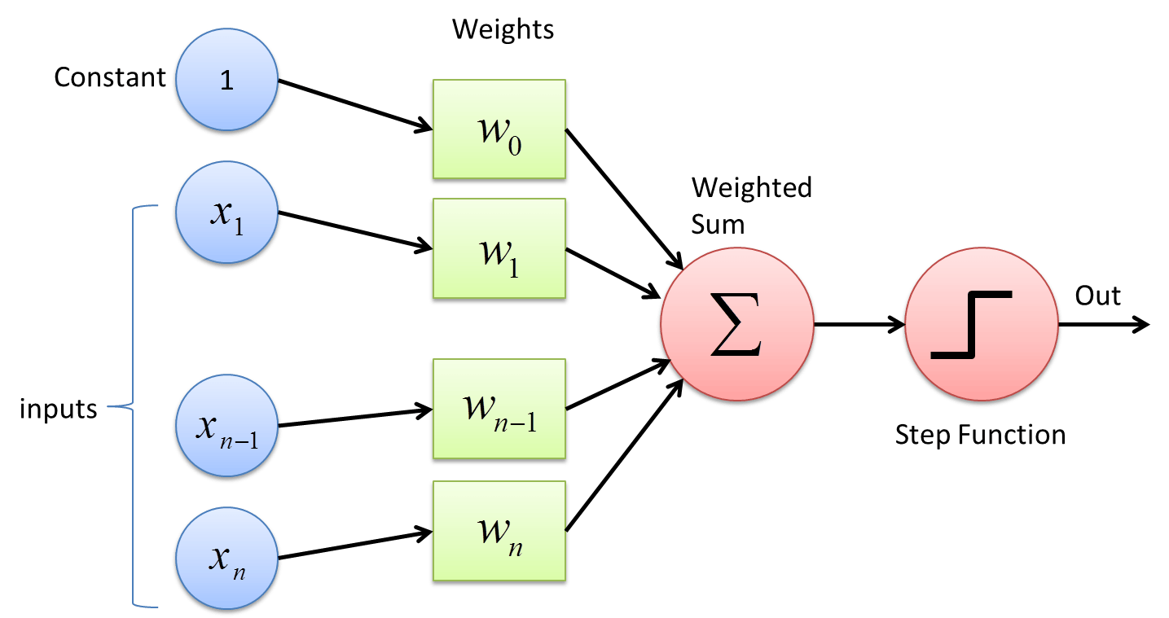
Figure 1: A graph showing how Perceptron solves problems using binary classification.
The step function compares this weighted sum to a threshold. If the input is larger than the threshold value, the output is 1; otherwise, it's 0. This is the most common activation function used in Perceptrons are represented by the Heaviside step function:
$$h\left(z\right)=\left\{\begin{aligned}0, &if z<threshold \\ 1, &if z >threshold\end{aligned}\right.$$Example: Perceptron in Action
Let’s take a simple example of classifying whether a given fruit is an apple or not based on two inputs: its weight (in grams) and its color (on a scale of 0 to 1, where 1 means red). The perceptron receives these inputs, multiplies them by their weights, adds a bias, and applies the activation function to decide whether the fruit is an apple or not.
- Input 1 (Weight): 150 grams
- Input 2 (Color): 0.9 (since the fruit is mostly red)
- Weights: [0.5, 1.0]
- Bias: 1.5
The perceptron’s weighted sum would be:
$$\left(150*0.5\right)+\left(0.9*1.0\right)+1.5=76.4$$
Let’s assume the activation function uses a threshold of 75. Since 76.4 > 75, the Perceptron classifies the fruit as an apple (output = 1).

Types of Perceptron
- Single-Layer Perceptron is a type of perceptron is limited to learning linearly separable patterns. It is effective for tasks where the data can be divided into distinct categories through a straight line. While powerful in its simplicity, it struggles with more complex problems where the relationship between inputs and outputs is non-linear.
- Multi-Layer Perceptron possess enhanced processing capabilities as they consist of two or more layers, adept at handling more complex patterns and relationships within the data.

2. Backward Propagation
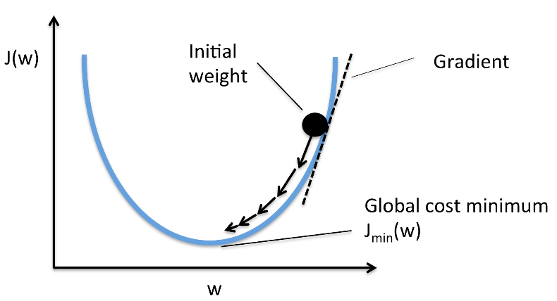
Back Propagation is also known as “Backward Propagation of Errors” and is a method used to train neural network. Its goal is to reduce the difference between the model’s predicted output and the actual output by adjusting the weights and biases in the network.
Figure 2: Gradient Descent optimization method.
- It often uses optimization algorithms like gradient descent or stochastic gradient descent. The algorithm computes the gradient using the chain rule from calculus allowing it to effectively navigate complex layers in the neural network to minimize the cost function.
Back Propagation plays a critical role in how neural networks improve over time. Here's why:
- Efficient Weight Update: It computes the gradient of the loss function with respect to each weight using the chain rule making it possible to update weights efficiently.
- Scalability: The Back Propagation algorithm scales well to networks with multiple layers and complex architectures making deep learning feasible.
- Automated Learning: With Back Propagation the learning process becomes automated, and the model can adjust itself to optimize its performance.
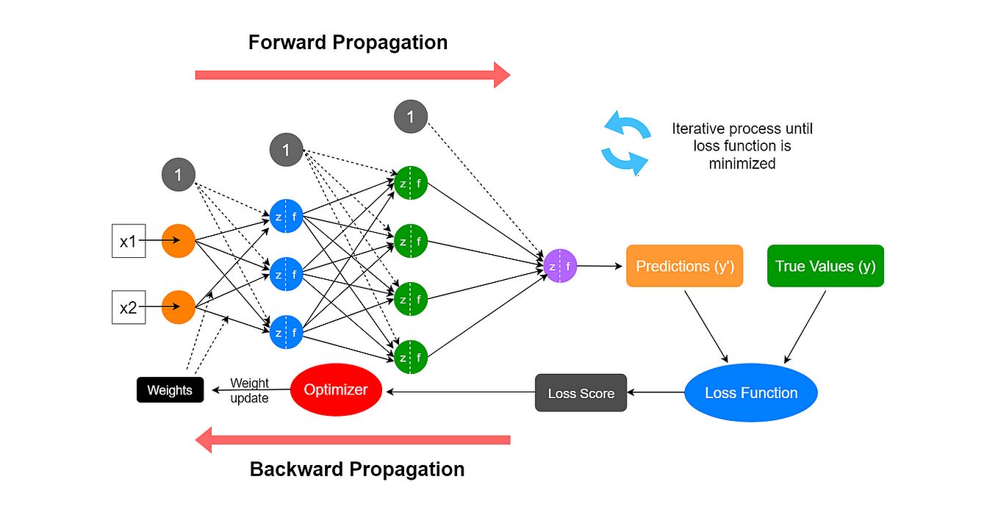
Figure 3: Graph of how typically a multi-layered neural network works and learns.
1. Forward Pass Work
In forward pass the input data is fed into the input layer. These inputs combined with their respective weights are passed to hidden layers. For example, in a network with two hidden layers (h1 and h2) the output from h1 serves as the input to h2. Before applying an activation function, a bias is added to the weighted inputs.
2. Backward Pass
In the backward pass the error (the difference between the predicted and actual output) is propagated back through the network to adjust the weights and biases. One common method for error calculation is the Mean Squared Error (MSE) given by:
$$MSE={(Predicted Output-True Output)}^{2}$$
Once the error is calculated the network adjusts weights using gradients which are computed with the chain rule. These gradients indicate how much each weight and bias should be adjusted to minimize the error in the next iteration.

2.1. Full Example of Backward Propagation
Let’s walk through an example of Back Propagation in machine learning. Assume the neurons use the sigmoid activation function for the forward and backward pass. The target output is 0.5 and the learning rate is 1.
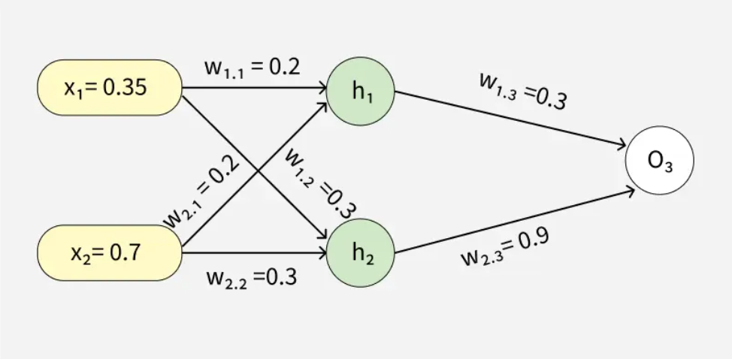
Figure 4:Example on Backward Propagation and how the neural network functions with Sigmoid Activation.

Forward Propagation
1. Initial Calculation
The weighted sum at each node is calculated using:
$$a_{j}=∑\left(w_{i,j}⋅x_{i}\right)$$
Where,
- $a_{j}$ is the weighted sum of all the inputs and weights at each node
- $W_{i,j}$​ represents the weights between the ith input and the jth neuron
- $X_{i}$​ represents the value of the ith input
And so, for each output node, we calculate it using the Sigmoid Function:
$$y_{j}=\frac{1}{1+e^{{-a}_{j}}}$$
For continuation of the problem and more information, visit the following website:
Backpropagation in Neural Network - GeeksforGeeks

3. Activation Functions
There are many types of Activation Functions, each with their own pros and cons.
The types include:
  - Sigmoid Function
  - Tanh Function
  - Relu
  - Leaky Relu
  - Prelu (Parametric Relu)
  - ELU
But some of them face a problem called Vanishing Gradient Problem.

3.1. Gradient Problem
In the realm of deep learning, the optimization process plays a crucial role in training neural networks. Gradient descent, a fundamental optimization algorithm, can sometimes encounter two common issues: vanishing gradients and exploding gradients.

3.1.2. What is Vanishing gradient?
The vanishing gradient problem is a challenge that emerges during backpropagation when the derivatives or slopes of the activation functions become progressively smaller as we move backward through the layers of a neural network. This phenomenon is particularly prominent in deep networks with many layers, hindering the effective training of the model.
The vanishing gradient problem is particularly associated with the sigmoid and hyperbolic tangent (tanh) activation functions because their derivatives fall within the range of 0 to 0.25 and 0 to 1, respectively. Consequently, extreme weights become very small, causing the updated weights to closely resemble the original ones.
How can we identify?
Identifying the vanishing gradient problem typically involves monitoring the training dynamics of a deep neural network.
- One key indicator is observing model weights converging to 0 or stagnation in the improvement of the model's performance metrics over training epochs.
- During training, if the loss function fails to decrease significantly, or if there is erratic behavior in the learning curves, it suggests that the gradients may be vanishing.
- Additionally, examining the gradients themselves during backpropagation can provide insights. Visualization techniques, such as gradient histograms or norms, can aid in assessing the distribution of gradients throughout the network.

3.2. Tanh Function:
Tanh (hyperbolic tangent) is a type of activation function that transforms its input into a value between -1 and 1.
It is mathematically defined as:
$$f\left(z\right)=\tanh\left(z\right)=\frac{e^{z}-e^{-z}}{e^{z}+e^{-z}}=\frac{sinh⁡(x)}{cosh⁡(x)}$$
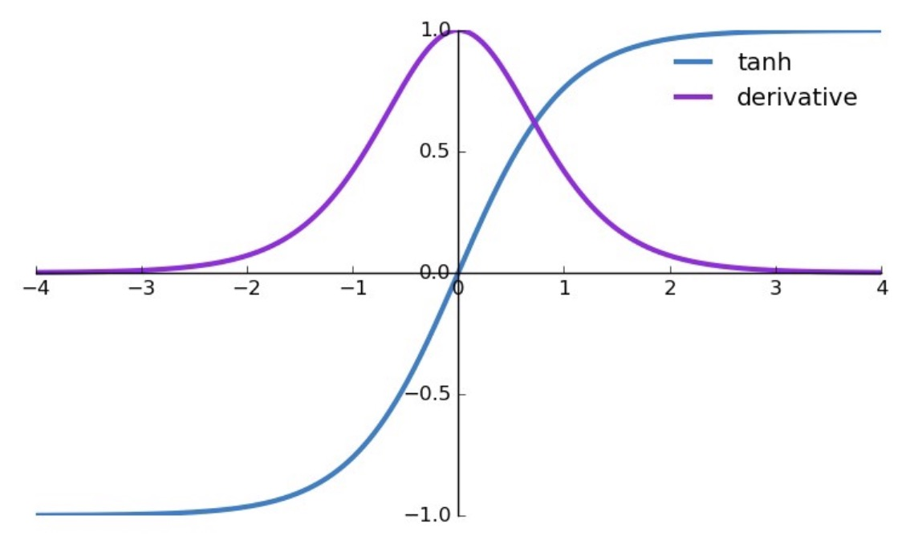
Figure 5: Tanh function graph and it's derivative.
Why Use Tanh in Neural Networks?
The tanh function has several advantages that make it widely used in neural networks:
- Non-linearity: Tanh introduces non-linearity to the model, which allows neural networks to learn complex patterns and relationships in the data. Without non-linear activation functions, a neural network would essentially behave as a linear model, no matter how many layers it has.
- Centered Around Zero: The output of the tanh function is centered around 0, unlike the sigmoid function, which outputs values between 0 and 1. This makes the tanh activation function more useful for many types of tasks, as the mean of the output is closer to zero, leading to more efficient training and faster convergence.
- Gradient Behavior: Tanh helps mitigate the vanishing gradient problem (to some extent), especially when compared to sigmoid activation. This is because the gradient of the tanh function is generally higher than that of the sigmoid, enabling better weight updates during backpropagation.
The derivative of the tanh Function:
The derivative is always positive and is maximum at 0, which helps with gradient-based optimization. However, just like the sigmoid, tanh also suffers from the vanishing gradient problem when the input values are too large or too small. This can cause gradients to become very small, leading to slower training in deeper networks.
Disadvantages of Tanh
- Vanishing Gradient Problem: Similar to the sigmoid function, tanh suffers from the vanishing gradient problem for large values of the input (both positive and negative). When the input to the tanh function is very large or very small, the gradient approaches zero, which can slow down or halt learning during backpropagation, especially in deep networks.
- Not Suitable for All Tasks: While tanh works well in many cases, it might not be the best option for all types of neural network architectures. For instance, ReLU (Rectified Linear Unit) has gained popularity for deep networks due to its simplicity and efficiency in mitigating the vanishing gradient problem.
- Sensitive to Outliers: Extreme values in the input can lead to saturated regions where the gradient is close to zero, making learning slow or ineffective. This could happen if the inputs to the tanh function are not scaled properly.

3.3. ReLU Function:
Rectified Linear Unit (ReLU) is a popular activation function used in neural networks, especially in deep learning models. It has become the default choice in many architectures due to its simplicity and efficiency. The ReLU function is a piecewise linear function that outputs the input directly if it is positive; otherwise, it outputs zero.
- In simpler terms, ReLU allows positive values to pass through unchanged while setting all negative values to zero. This helps the neural network maintain the necessary complexity to learn patterns while avoiding some of the pitfalls associated with other activation functions, like the vanishing gradient problem.
The function can be described as:
$$f\left(z\right)=\max\left(0,z\right)$$
Where:
- Z is the input to the neuron.
- The function returns z if z is greater than 0.
- If z is less than or equal to 0, the function returns 0.
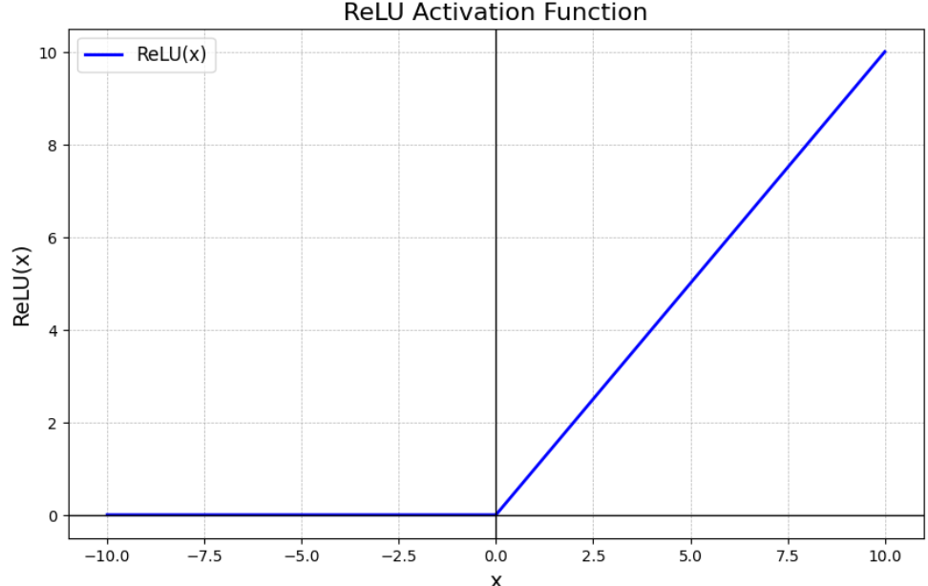
Figure 6: ReLU graph function plot.
Why is ReLU Popular?
- Simplicity: ReLU is computationally efficient as it involves only a thresholding operation. This simplicity makes it easy to implement and compute, which is important when training deep neural networks with millions of parameters.
- Non-Linearity: Although it seems like a piecewise linear function, ReLU is still a non-linear function. This allows the model to learn more complex data patterns and model intricate relationships between features.
- Sparse Activation: ReLU's ability to output zero for negative inputs introduces sparsity in the network, meaning that only a fraction of neurons activate at any given time. This can lead to more efficient and faster computation.
- Gradient Computation: ReLU offers computational advantages in terms of backpropagation, as its derivative is simple—either 0 (when the input is negative) or 1 (when the input is positive). This helps to avoid the vanishing gradient problem, which is a common issue with sigmoid or tanh activation functions.
Drawbacks of ReLU
While ReLU has many advantages, it also comes with its own set of challenges:
- Dying ReLU Problem: One of the most significant drawbacks of ReLU is the "dying ReLU" problem, where neurons can sometimes become inactive and only output 0. This happens when large negative inputs result in zero gradient, leading to neurons that never activate and cannot learn further.
- Unbounded Output: Unlike other activation functions like sigmoid or tanh, the ReLU activation is unbounded on the positive side, which can sometimes result in exploding gradients when training deep networks.
- Noisy Gradients: The gradient of ReLU can be unstable during training, especially when weights are not properly initialized. In some cases, this can slow down learning or lead to poor performance.

3.4. Leeky ReLU:
Leaky ReLU introduces a small slope for negative values instead of outputting zero, which helps keep neurons from "dying.".
$$f\left(x\right)=\left\{\begin{aligned}x, &if x>0 \\ ax, &if x≤0\end{aligned}\right.$$
where α is a small constant (often set to 0.01).
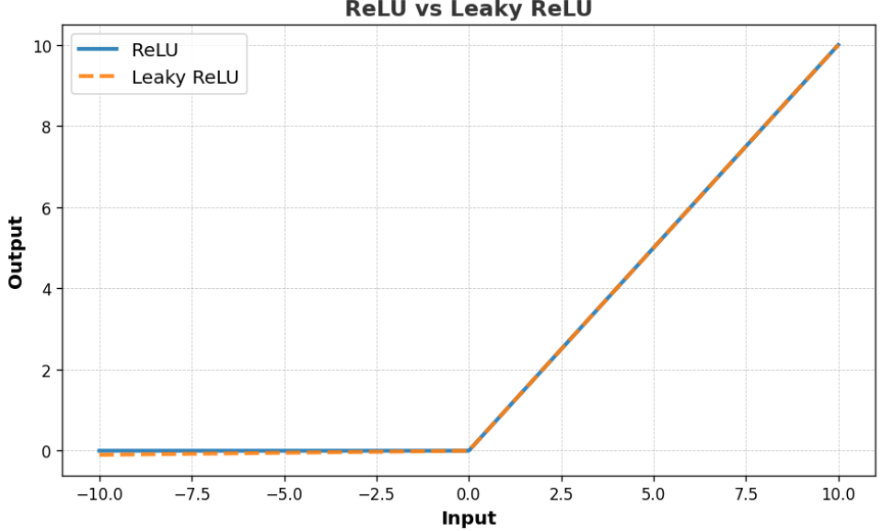
Figure 7: ReLU versus Leeky ReLU graph.

3.5. Parametric ReLU:
Parametric ReLU (PReLU) is an extension of Leaky ReLU, where the slope of the negative part is learned during training. The formula is as follows:
$$f\left(x\right)=\left\{\begin{aligned}x, &if x≥0 \\ ax, &if x<0\end{aligned}\right.$$
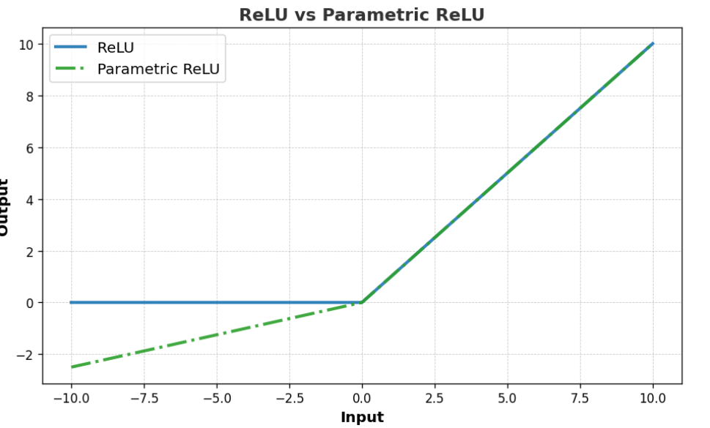
Figure 8: ReLU vs Parametric ReLU graph.
In PReLU, α can adapt to different training conditions, making it more flexible compared to Leaky ReLU, where the slope is predefined. This allows the model to learn the best negative slope for each neuron during the training process.

3.6. Exponential Linear Unit (ELU):
Exponential Linear Unit (ELU) adds smoothness by introducing a non-zero slope for negative values, which reduces the bias shift. It’s known for faster convergence in some models.
The formula for Exponential Linear Unit (ELU) is:
$$f\left(x\right)=\left\{\begin{aligned}x, &if x≥0 \\ a(\exp\left(x\right)-1), &if x<0\end{aligned}\right.$$
Where:
- x is the input.
- α is a positive constant that defines the value for negative inputs (often set to 1).
- For x ≥ 0, the output is simply x (same as ReLU).
- For x < 0, the output is an exponential function of x, shifted by 1 and scaled by α.
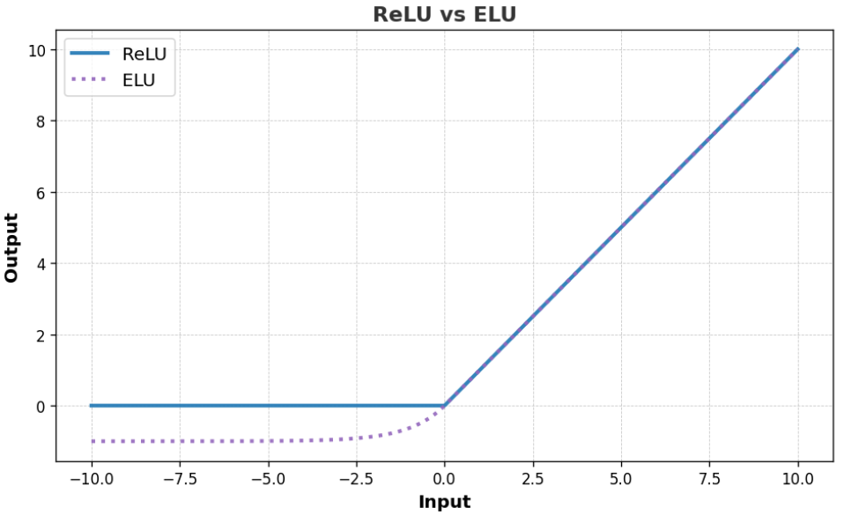
Figure 9: ReLU vs ELU graph.

3.7. Soft max Activation Functions:
Softmax function is a mathematical function that converts a vector of raw prediction scores (often called logits) from the neural network into probabilities. These probabilities are distributed across different classes such that their sum equals 1. Essentially, Softmax helps in transforming output values into a format that can be interpreted as probabilities, which makes it suitable for classification tasks.
- Softmax is an activation function commonly used in neural networks for multi-classification problems.
Formula of Softmax function:
$$softmax\left(Z_{i}\right)=\frac{e^{Z_{i}}}{\sum_{j=1}^{k}{e^{Z_{j}}}}$$
Where:
- $Z_{i}$ is the logit (the output of the previous layer in the network) for the i^{th}class.
- K is the number of classes.
- $e^{Z_{i}}$​​ represents the exponential of the logit.
- the sum of exponentials across all classes.

Why Use Softmax?
- Multi-Class Classification: Softmax is ideal for problems involving more than two classes, where the goal is to predict a single class out of many. The function's ability to generate a probability distribution over classes makes it particularly useful in classification models.
- Probabilistic Interpretation: Since Softmax converts logits into probabilities, the output is easily interpretable. You can not only determine the most likely class but also gauge the confidence of the model in that prediction.
- Handling Multiple Classes Simultaneously: The sum-to-one property of Softmax ensures that all possible classes are considered together. This holistic approach ensures that each prediction takes into account all classes rather than just focusing on one or two.
For more information & an example on using Softmax, visit Softmax Activation Function in Neural Networks - GeeksforGeeks

4. Optimizers
During the training process of a Neural Network, our aim is to try and minimize the loss function, by updating the values of the parameters (Weights) and make our predictions as accurate as possible. But how exactly do you do that? Then comes the question of how do you change the parameters of your model and by how much?
- Now if you use brute force method to identify the best parameters for your Deep Neural Network it will take about 3.42*10⁵⁰ years for the world’s fastest supercomputer Sunway Taihulight at a speed of 93 PFLOPS (Peta Fluid Operations/Sec), while a normal computer works at several Giga FLOPS.
This is where optimizer comes into the picture. It tries to lower the loss function by updating the model parameters in response to the output of the loss function.
Updating Weights:
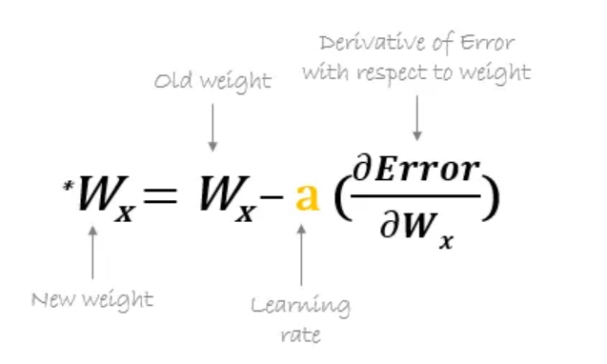
Before going deep into various types of optimizers, it is very essential to know that the most important function of the optimizer is to update the weights of the learning algorithm to reach the least cost function. Here is the formula used by all the optimizers for updating the weights with a certain value of the learning rate.
Figure 10: Formula used by all optimizers to update the learning rate based on loss function.

4.1. Gradient Descent:
This is one of the oldest and the most common optimizers used in neural networks, best for the cases where the data is arranged in a way that it possesses a convex optimization problem. It will try to find the least cost function value by updating the weights of your learning algorithm and will come up with the best-suited parameter values corresponding to the Global Minima.

There are only 2 parameters for GD to note:
- Epochs.
- Iteration.
Where:
- Epochs: When the model goes through forward propagation stage and calculates the loss function result at the end, then goes through backward propagation while updating the weights to try and reduce the loss function and obtain best value.
- Iterations: It is 1 Epoch = 1 Iteration.
Advantages:
- Convergence will happen (slowly but surely)
Disadvantages:
- Huge Resources are needed as when the dataset increases, Ram & CPU consumption increases exponentially.

4.2. Stochastic Gradient Descent (SGD):
This is another variant of the Gradient Descent optimizer with an additional capability of working with data with a non-convex optimization problem.
Rather than going for batch processing, this optimizer focuses on performing one update at a time. It is therefore usually much faster, also the cost function minimizes after each iteration (EPOCH). It performs frequent updates with a high variance that causes the objective function(cost function) to fluctuate heavily.
So, for example:
- If the data was 1000 records, then at Epoch 1, there will be 1000 iterations because each time stochastic gradient descent only takes 1 data point, and at Epoch 2 there will also be 1000 iterations and so on.
Advantages:
- Solve resource issues of GD.
Disadvantages:
- Time complexity, more time needed as a lot of iterations happen.
- Convergence will take more time
- Noise will get generated (Descent will not be a smooth line)

4.3. Mini Batch SGD:
Mini-batch gradient descent is a optimization method that updates model parameters using small subsets of the training data called mini-batches. This technique offers a middle path between the high variance of stochastic gradient descent and the high computational cost of batch gradient descent.
So, for example:
- We introduce a new parameter called batch size, if our data is 10000 records and we make the batch size 100 so that means the number of iterations will be $\frac{10000}{100}=100$ iterations per 1 Epoch.
Advantages:
- Convergence speed will increase compared to SGD.
- Noise will be less.
- More Efficient use of resources.
Disadvantages:
- Noise still exists.

4.4. SGD with Momentum:
Stochastic Gradient Descent (SGD) is a popular optimization algorithm used in machine learning to minimize the loss function by updating model parameters iteratively. Momentum is an enhancement to SGD that helps to overcome some of its limitations, particularly in terms of convergence speed and stability.

4.5. Adaptive gradient descent (ADAGRAD):
AdaGrad adapts the learning rate for each parameter based on historical gradient information. The learning rate decreases over time, making AdaGrad effective for sparse features.
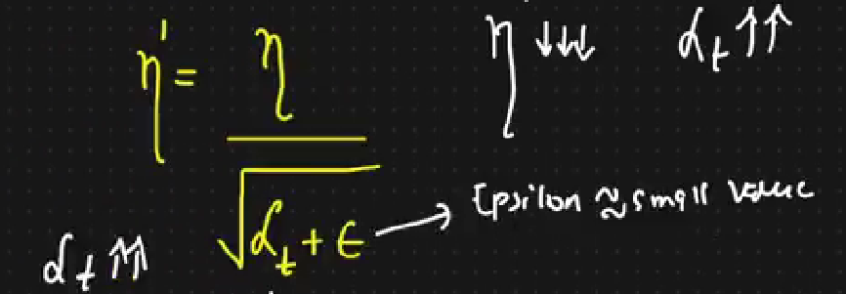
Figure 11: Equation of Updating the learning rate using AdaGrad.
Where:
- The $ϵ$ epsilon is used to ensure that the denominator is never equal to zero.
- We get a smaller number learning rate everytime.

When to Use Adagrad?
Adagrad is ideal for:
- Problems with sparse data and features (e.g., natural language processing, recommender systems).
- Tasks where features have different levels of importance and frequency.
- Training models that do not require a very fast convergence rate but benefit from a more stable optimization process.
Disadvantages:
The problem is that usually the learning rate becomes so small over time so that when we minus the updated weight from the original weight, it is almost approximately equal to the original weight, so no weight update is happening like in Vanishing gradient problem.
Read more about AdaGrad here: Adagrad Optimizer in Deep Learning - GeeksforGeeks

4.6. Root mean square propagation (RMSPROP):
RMSProp (Root Mean Square Propagation) is an adaptive learning rate optimization algorithm designed to improve the performance and speed of training deep learning models.
- It is a variant of the gradient descent algorithm which adapts the learning rate for each parameter individually by considering the magnitude of recent gradients for those parameters.
- This adaptive nature helps in dealing with the challenges of non-stationary objectives and sparse gradients commonly encountered in deep learning tasks.
This is the formula of RMSPROP:
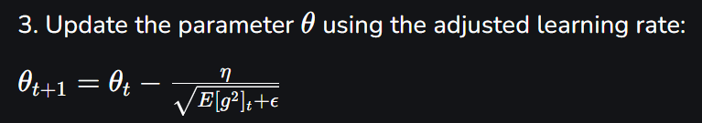
Parameters Used in RMSProp
- Learning Rate (η): Controls the step size during the parameter updates. RMSProp typically uses a default learning rate of 0.001, but it can be adjusted based on the specific problem.
- Decay Rate (γ): Determines how quickly the moving average of squared gradients decays. A common default value is 0.9, which balances the contribution of recent and past gradients.
- Epsilon (ϵ): A small constant added to the denominator to prevent division by zero and ensure numerical stability. A typical value for ϵϵ is 1e-8.

5. OpenCV
OpenCV (Open-Source Computer Vision Library) is an open-source software toolkit for computer vision and machine learning tasks. Originally developed by Intel, it is now maintained by the OpenCV Foundation and a large community of contributors. OpenCV enables developers to process and analyze visual data such as images and videos with efficiency.
Why OpenCV Matters
OpenCV has become a fundamental tool in computer vision development with applications like facial recognition, augmented reality and self-driving cars. It offers optimized algorithms for real-time image and video analysis, making it ideal for applications that demand speed, accuracy and scalability.
Its design prioritizes computational efficiency through low-level implementation, while offering Python for ease of use. Hence, OpenCV offers the flexibility and performance needed to handle visual data intelligently.
How Computers See Images
Unlike humans, computers don’t “see” images, they interpret them as numeric matrices:
- Pixel Values: Each image is made up of pixels and each pixel holds values for color and brightness. In color images, each pixel generally has three values (Red, Green, Blue).
- Matrix Representation: The image is stored as a NumPy array, where each entry shows a pixel’s intensity. Grayscale images are 2D arrays and color images are 3D arrays.
- Processing: Algorithms manipulate these arrays to apply transformations like edge detection, blurring or object detection.
Functionalities of OpenCV
OpenCV provides a wide set of capabilities that make it versatile for various computer vision tasks:
- Image and Video I/O: Read, display and save images or video files.
- Image Processing: Perform operations like resizing, filtering, thresholding and color transformations.
- Object Detection: Detect faces, shapes and features using built-in classifiers and detectors.
- Machine Learning: Train and apply models for classification and clustering.
- Computational Photography: Apply advanced effects like denoising and panorama stitching.

5.1. Color Spaces Supported:
Color Spaces in OpenCV
OpenCV provides a variety of color spaces to process and analyze images effectively. Each color space serves a specific purpose, and the choice depends on the task at hand. Below are some commonly used color spaces in OpenCV:
1. BGR (Blue, Green, Red)
- Default color space for images in OpenCV.
- Images are loaded in this format by default.
- Example: cv2.imread('image.jpg') loads the image in BGR format.
2. Grayscale
- Converts the image to shades of gray.
- Useful for tasks like edge detection, thresholding, and feature extraction.
- Conversion: cv2.cvtColor(image, cv2.COLOR_BGR2GRAY)
3. HSV (Hue, Saturation, Value)
- Separates color information (Hue) from intensity (Value).
- Ideal for color-based segmentation and object detection.
- Conversion: cv2.cvtColor(image, cv2.COLOR_BGR2HSV)
4. LAB (CIE LAB)
- Represents colors in a way that is closer to human perception.
- Useful for color correction and enhancement.
- Conversion: cv2.cvtColor(image, cv2.COLOR_BGR2LAB)
5. YCrCb (Luminance and Chrominance)
- Separates luminance (Y) from chrominance (Cr, Cb).
- Commonly used in video compression (e.g., JPEG, MPEG).
- Conversion: cv2.cvtColor(image, cv2.COLOR_BGR2YCrCb)
6. RGB (Red, Green, Blue)
- Similar to BGR but with a different channel order.
- Conversion: cv2.cvtColor(image, cv2.COLOR_BGR2RGB)
7. Other Color Spaces
- XYZ: Used in color matching and device-independent color representation.
- HLS (Hue, Lightness, Saturation): Similar to HSV but with Lightness instead of Value.
Example Code in Python
import cv2

# Load an image
image = cv2.imread('image.jpg')

# Convert to different color spaces
gray = cv2.cvtColor(image, cv2.COLOR_BGR2GRAY)
hsv = cv2.cvtColor(image, cv2.COLOR_BGR2HSV)
lab = cv2.cvtColor(image, cv2.COLOR_BGR2LAB)

# Display the results
cv2.imshow('Original', image)
cv2.imshow('Grayscale', gray)
cv2.imshow('HSV', hsv)
cv2.imshow('LAB', lab)
cv2.waitKey(0)
cv2.destroyAllWindows()
dsa

5.2. Working with Video Files:
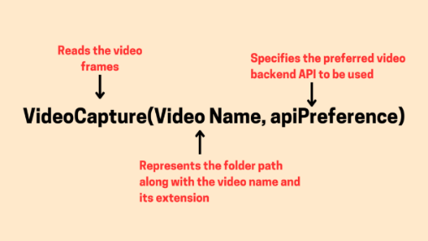
Reading a video file requires processing each frame individually, and then displaying or storing it as needed. OpenCV provides the VideoCapture() function for this purpose, allowing users to load video files and access webcam streams in real-time.
Figure 12: VideoCapture function.
On the other hand, writing a video file requires assembling a sequence of processed frames and encoding them into a specific format. This is achieved using VideoWriter(), which enables users to save frames as a video file with customizable resolution, frame rate, and encoding options.

5.2.1. Reading a Video Frame
Code Example:
import cv2

# Open the video file
cap = cv2.VideoCapture("C:/Users/ssabb/Downloads/Hashira.mp4")

# Check if the video was opened successfully
if not cap.isOpened():
print("Error: Could not open video file.")
else:
print("Video file opened successfully!")

# Read the first frame to confirm reading
ret, frame = cap.read()

if ret:

# Display the frame using imshow
cv2.imshow("First Frame", frame)
cv2.waitKey(0) # Wait for a key press to close the window
cv2.destroyAllWindows() # Close the window
else:
print("Error: Could not read the frame.")

# Release the video capture object
cap.release()
Explanation:
The code first opens the video file using VideoCapture(). It checks if the file was opened successfully using isOpened(). The first frame is read using cap.read(), and a confirmation message is printed based on whether the frame was retrieved.
- ret: The ret variable is a boolean value that indicates whether the frame was successfully captured. It returns True if the frame was read correctly and False if there was an issue.
- frame: The frame variable contains the actual image (frame) that was read from the video file or image sequence. It’s returned as a NumPy array in Python or as a cv::Mat object in C++. This array holds the pixel values that represent the frame, which can then be processed, displayed, or manipulated further in the program.
After reading the first frame with cap.read(), the frame is displayed using imshow(). The waitKey(0) function pauses the execution and waits for the user to press any key. Once a key is pressed, destroyAllWindows() closes the window.
The cap.release() function ensures that system resources are freed after the operation.

5.2.2. Reading a Whole Video
Example Code:
import cv2

# Open the video file
cap = cv2.VideoCapture("C:/Users/ssabb/Downloads/Hashira2.mp4")

# Check if the video was opened successfully
if not cap.isOpened():
print("Error: Could not open video file.")
else:
print("Video file opened successfully!")

# Get video properties (e.g., frame count and frame width)
frame_count = int(cap.get(cv2.CAP_PROP_FRAME_COUNT)) # Get total number of frames in the video
fps = cap.get(cv2.CAP_PROP_FPS) # Get frames per second (FPS)
print(f"Total frames: {frame_count}, FPS: {fps}")

# Read and display each frame of the video
while True:
ret, frame = cap.read()
if not ret:
print("End of video or error occurred.")
break

# Display the frame
cv2.imshow("Video Frame", frame)

# Wait for 1ms for key press to continue or exit if 'q' is pressed
if cv2.waitKey(1) & 0xFF == ord('q'):
break

# Release the video capture object and close any OpenCV windows
cap.release()
cv2.destroyAllWindows()
Explanation:
Inside a while loop, each frame of the video is read with cap.read(). If the frame is successfully retrieved, it is displayed using imshow(). The loop continues displaying frames until there are no more frames to read or if the user presses the ‘q’ key (this is checked using waitKey()). The & 0xFF in Python ensures we are checking the lower byte of the returned key value.
Once the video ends or ‘q’ is pressed, we release the video capture object with cap.release() and close all OpenCV windows using destroyAllWindows().
The .get() method in OpenCV is used to retrieve various properties or metadata about a video, such as the number of frames (CAP_PROP_FRAME_COUNT), the frame width (CAP_PROP_FRAME_WIDTH), frame height (CAP_PROP_FRAME_HEIGHT), and more.
Common Uses of get()
- CAP_PROP_FRAME_COUNT: To get the total number of frames in the video.
- CAP_PROP_FPS: To get the frames per second (FPS) of the video.
- CAP_PROP_FRAME_WIDTH and CAP_PROP_FRAME_HEIGHT: To get the dimensions of each frame (width and height).

5.2.3. Writing a Video File
To write a video in OpenCV, we first open the video file using cv2.VideoCapture() in Python or cv::VideoCapture in C++. After successfully opening the video, we retrieve its properties, such as frame width and height, using cv2.CAP_PROP_FRAME_WIDTH and cv2.CAP_PROP_FRAME_HEIGHT.
Next, we set up the video writer by defining the codec with cv2.VideoWriter_fourcc() in Python or cv::VideoWriter::fourcc() in C++, specifying the FPS and resolution. Inside a loop, we continuously read frames using cap.read(), write each frame to the output video using out.write(frame), and display it using cv2.imshow(). The loop continues until the video ends (ret == False) or the user presses the ‘q’ key to exit.
Finally, we release the video objects with cap.release() and out.release(), ensuring all resources are freed, and close all OpenCV windows using cv2.destroyAllWindows().
import cv2

# Open the video file
cap = cv2.VideoCapture("C:/Users/ssabb/Downloads/input.mp4")

# Check if the video was opened successfully
if not cap.isOpened():
print("Error: Could not open video file.")
exit()

# Get frame width and height
frame_width = int(cap.get(cv2.CAP_PROP_FRAME_WIDTH))
frame_height = int(cap.get(cv2.CAP_PROP_FRAME_HEIGHT))

# Define the codec and create VideoWriter object
fourcc = cv2.VideoWriter_fourcc(*"XVID")
out = cv2.VideoWriter("output.avi", fourcc, 30.0, (frame_width, frame_height))
while True:
ret, frame = cap.read()
if not ret:
print("End of video or error occurred.")
break

# Write the frame to the output video file
out.write(frame)

# Display the frame
cv2.imshow("Frame", frame)
if cv2.waitKey(1) & 0xFF == ord('q'):
break

# Release everything
cap.release()
out.release()
cv2.destroyAllWindows()

5.2.4. Camera Feed
Opening a live webcam feed or camera is crucial to apply image segmentation, Edge detection, and or other image processing techniques.

1. Determine Cameras:
- The function returns a list of available cameras to tell the user which index number to use with video capture.
Code:
def list_available_cameras():
"""Check available camera indices"""
available_cameras = []
for i in range(0, 5):
cap = cv.VideoCapture(i)
if cap.isOpened():
available_cameras.append(i)
cap.release()
return available_cameras

Camera_lst = list_available_cameras()

print("The Available Cameras are: ", Camera_lst[0])

2. Webcam reading
The following code’s purpose is to read the webcam or camera feed and apply any type of preprocessing we want on the camera feed in real time.
def edge_detection(frame):
# Apply blur then convert to gray scale
blurred_frame = cv.blur(frame, (5, 5))
gray_frame = cv.cvtColor(blurred_frame, cv.COLOR_BGR2GRAY)

# Apply Sobel Edge Detection
sobel_x = cv.Sobel(gray_frame, cv.CV_64F, 1, 0, ksize=5)
sobel_y = cv.Sobel(gray_frame, cv.CV_64F, 0, 1, ksize=5)
sobel_combined = cv.magnitude(sobel_x, sobel_y)

# Return the converted 8-bit frame with Sobel Edge Detection
sobel_8bit = np.uint8(sobel_combined)
return sobel_8bit

webcam = cv.VideoCapture(0)

if not webcam.isOpened():
print('Unable to load camera.')
exit()

while True:
ret, frame = webcam.read()

if not ret:
print('Unable to capture frame.')
break
else:
# Apply Processing to frame and show video feed
sobel_frame = edge_detection(frame)
cv.imshow('Original', frame)
cv.imshow('Sobel Edge Detection', sobel_frame)

if cv.waitKey(1) & 0xFF == ord('q'):
break

webcam.release()
cv.destroyAllWindows()
In this instance, I’ve applied Sobel edge detection on my webcam and showed two feeds.
The original feed and the Sobel edge detection feed side by side to see the differences.

5.3. Color Thresholding:
Image Thresholding is an intensity transformation function in which the values of pixels below a particular threshold are reduced, and the values above that threshold are boosted. This generally results in a bilevel image at the end, where the image is composed of black and white pixels. Thresholding belongs to the family of point-processing techniques.
There are various ways of performing thresholding (Adaptive, Inverse, etc.).

5.3.1. Using inRange() Function
Color detection is an essential task in computer vision, and OpenCV makes it easy to implement using the cv::inRange() function. This function is beneficial in applications like object tracking, robotics, and augmented reality, where isolating specific colors in an image is crucial.
OpenCV uses the HSV (Hue, Saturation, Value) color space, which separates color information from intensity, making it easier to detect colors under varying lighting conditions.
What is HSV Color Space?
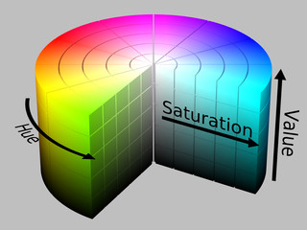
The HSV color space represents colors in a way that's more aligned with human perception. Unlike the RGB color space, which mixes red, green, and blue light, HSV separates hue (the type of color) from saturation (color intensity) and value (brightness). This separation helps isolate colors more effectively, especially under different lighting conditions.
Figure 13: HSV Color Space explanation.
- Hue (H): The type of color, ranging from 0° to 179° in OpenCV (as opposed to 0° to 360°).
- Saturation (S): Intensity or purity of the color, ranging from 0 to 255.
- Value (V): Brightness of the color, ranging from 0 to 255.
The function cv::inRange() isolates colors within a given range in the HSV color space. The general syntax is:
cv2.inRange(src, lowerb, upperb)
- src: The input image in HSV color space.
- lowerb: The lower boundary of the color you want to detect (as a tuple of HSV values).
- upperb: The upper boundary of the color.
It returns a binary mask, where pixels inside the specified range are white (255), and pixels outside the range are black (0).

Steps to use inRange() Function:
1. Convert the Image to HSV Color Space
The first step is to convert your image from BGR (default in OpenCV) to HSV color space. This is essential because cv::inRange() operates in the HSV space.
hsv_image = cv2.cvtColor(image, cv2.COLOR_BGR2HSV)
2. Determine the Target Color's HSV Range
To detect a specific color, you need to define the correct HSV range for that color. There are two main methods to determine HSV values:
- Use a color picker tool: You can use tools like GIMP or an online HSV color picker to get the HSV values of the color. Ensure that the Hue values are converted to OpenCV's range (0–179).
- Create interactive trackbars: An interactive OpenCV script allows you to adjust HSV values in real-time and observe how the mask changes. This can help you fine-tune the range.

3. Set the Lower and Upper HSV Boundaries
Once you've determined the HSV range for your target color, you can set the lower and upper bounds:
lower_bound = np.array([H_min, S_min, V_min])
upper_bound = np.array([H_max, S_max, V_max])
For example, if you are detecting blue, the typical HSV range would be:
lower_blue = np.array([100, 150, 0])
upper_blue = np.array([140, 255, 255])

4. Apply cv::inRange() for Color Detection
Now that you have defined your HSV boundaries, apply the cv::inRange() function to create a binary mask where the target color is detected.
mask = cv2.inRange(hsv_image, lower_bound, upper_bound)
Example for Detecting Blue:
lower_blue = np.array([100, 150, 0])
upper_blue = np.array([140, 255, 255])
blue_mask = cv2.inRange(hsv_image, lower_blue, upper_blue)

5. Bitwise ‘AND’ to Extract the Color
To highlight the detected color, apply the mask using a bitwise AND operation:
result = cv2.bitwise_and(image, image, mask=blue_mask)

5.4. Image Resizing, Rescaling, and Interpolation
Resizing an image means changing its width and height, shrinking it for faster loading or enlarging it for better visibility.
This is a common task in image processing and machine learning for various reasons:
- Reduce training time in neural networks by decreasing input image size, which lowers number of input nodes.
- Fit images to display or processing requirements sometimes images must meet specific size criteria.
- Zoom in or out of an image for better visualization.

resized_img = cv2.resize(img, fx, fy, (width, height), interpolation = cv.interpol)

Where there are many interpolation types:
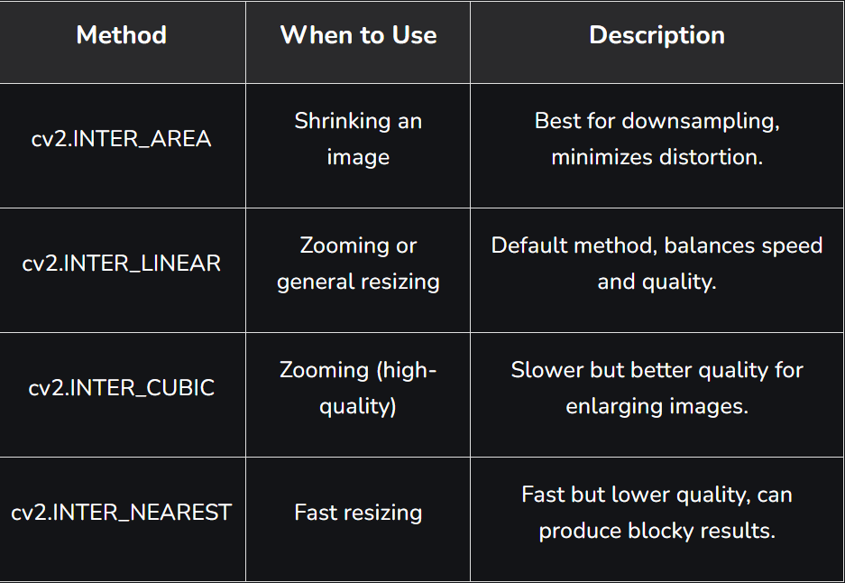
There are also:
Figure 14: Types of Interpolation.
- INTER_LANCZOS4: This option uses Lanczos interpolation over 8 x 8 pixel neighborhood technique. It uses Fourier series and Chebyshev polynomials and is suited for images with large number of small size details.
- INTER_NEAREST_EXACT: INTER_NEAREST_EXACT is a modification of INTER_NEAREST with bit level accuracy.
- INTER_MAX: This option uses mask for interpolation codes.
For Rescaling the image, we use:
The ‘fx’, and the ‘fy’ variable, where if we make both of them 0.1 (that means 10%) that means we want the image scaled down to 10% of it’s original resolution while keeping the aspect ratio the same.

5.5. Image Flipping, Rotating, and Resizing
With OpenCV, we have multiple functions that can flip, rotate, and resize an image.

5.5.1. Flip an Image:
To flip an image using OpenCV in Python, you can use the cv2.flip() function. This function allows you to flip an image along different axis: horizontally, vertically, or both. Here's a quick guide:
Syntax
cv2.flip(src, flipCode)
- src: The input image (as a NumPy array).
- flipCode:
  - 0: Flip vertically.
  - 1: Flip horizontally.
  - -1: Flip both vertically and horizontally.

5.5.2. Rotating an Image:
To rotate an image using OpenCV, you can use the cv2.rotate() method for fixed rotations (90°, 180°, 270°) or the cv2.getRotationMatrix2D() method for custom angles.

Example on Fixed rotations using cv.rotate() function:
import cv2

# Load the image
image = cv2.imread('image.jpg')

# Rotate 90 degrees clockwise
rotated_90 = cv2.rotate(image, cv2.ROTATE_90_CLOCKWISE)

# Rotate 180 degrees
rotated_180 = cv2.rotate(image, cv2.ROTATE_180)

# Rotate 90 degrees counterclockwise (270° clockwise)
rotated_270 = cv2.rotate(image, cv2.ROTATE_90_COUNTERCLOCKWISE)

# Display the rotated image
cv2.imshow('Rotated Image', rotated_90)
cv2.waitKey(0)
cv2.destroyAllWindows()

Example on custom rotation angles using cv.getRotationMatrix2D():
import cv2
import numpy as np

# Load the image
image = cv2.imread('image.jpg')

# Get the image dimensions
(h, w) = image.shape[:2]
center = (w // 2, h // 2)

# Define the rotation angle and scale
angle = 45 # Rotate 45 degrees
scale = 1.0 # Keep the original scale

# Get the rotation matrix
rotation_matrix = cv2.getRotationMatrix2D(center, angle, scale)

# Perform the rotation
rotated = cv2.warpAffine(image, rotation_matrix, (w, h))

# Display the rotated image
cv2.imshow('Rotated Image', rotated)
cv2.waitKey(0)
cv2.destroyAllWindows()

Example on Rotating with boundaries:
To avoid cropping during rotation, you can use imutils.rotate_bound:
import cv2
from imutils import rotate_bound

# Load the image
image = cv2.imread('image.jpg')

# Rotate the image while preserving the entire content
rotated = rotate_bound(image, 45)

# Display the rotated image
cv2.imshow('Rotated Image', rotated)
cv2.waitKey(0)
cv2.destroyAllWindows()
These methods allow you to rotate images efficiently with OpenCV. Choose the one that best fits your needs!

5.5.3. Cropping an Image:
Cropping an image is a fundamental operation in image processing, often used to remove unwanted areas or to focus on a specific region of interest (ROI). OpenCV, a popular computer vision library, allows you to crop images easily using NumPy array slicing.

Crop the Image
To crop the image, use NumPy array slicing. Specify the start and end indices for the rows and columns.
cropped_image = img[80:280, 150:330] # Slicing to crop the image
Where in this case, we used cv.imread() and stored the original image in a variable named ‘img’, and we used normal array slicing to crop the image.
Where:
- x_start: is on the 80th pixel from the x-axis of the image.
- x_end: is on the 280th pixel from the x-axis of the image.
- y_start: is on the 150th pixel from the y-axis of the image.
- y_end: is on the 330th pixel from the y-axis of the image.
Important Considerations
- Image Dimensions: Ensure you know the dimensions of the image before cropping. Use img.shape to get the height, width, and number of channels.
- Slicing: The slicing syntax is image[startY:endY, startX:endX]. The first dimension represents the rows (height), and the second dimension represents the columns (width).
- Saving the Image: Use cv2.imwrite() to save the cropped image to a file.

5.6. Draw Lines & Shapes
OpenCV provides many drawing functions to draw geometric shapes and write text on images. Let's see some of the drawing functions and draw geometric shapes on images using OpenCV.
Some of the drawing functions are:
- cv2.line(): Used to draw line on an image.
- cv2.rectangle(): Used to draw rectangles on an image.
- cv2.circle(): Used to draw circles on an image.
- cv2.putText(): Used to write text on image.

5.6.1. Drawing Lines:
Function syntax and parameters:
cv2.line(imageObjectName, ('start_coordinates'), ('end_coordinates'), ('color_in_bgr'), 'line_thickness')
Full example on drawing a line:
import numpy as np
import cv2

# Creating a black image with 3 channels
# RGB and unsigned int datatype
img = np.zeros((400, 400, 3), dtype = "uint8")

# Creating line
cv2.line(img, (20, 160), (100, 160), (0, 0, 255), 10)

cv2.imshow('dark', img)

# Allows us to see image
# until closed forcefully
cv2.waitKey(0)
cv2.destroyAllWindows()

5.6.2. Drawing a Rectangle:
Function Syntax and Parameters:
cv2.rectangle(imageObjectName, ('top_left_vertex_coordinates'), ('lower_right_vertex_coordinates'), ('stroke_color_in_bgr'), 'stroke_thickness')
- To completely fill the rectangle, we use “-1” for the ‘stroke_thickness’ parameter.

5.6.3. Drawing a Circle:
Function Syntax and Parameters:
cv2.circle(imageObjectName, ('center_coordinates'), ('circle_radius'), ('color_in_bgr'), 'stroke_thickness')

5.6.4. Drawing an Ellipse:
Function Syntax and Parameters:
# Draw the ellipse on the image
image = cv2.ellipse(image, center_coordinates, axesLength, angle, startAngle, endAngle, color, thickness)

5.7. Writing text:
Function syntax and Parameters:
cv2.putText(image, text, position, font, font_scale, color, thickness)
Key Parameters:
- text: The string you want to display.
- position: Coordinates for the bottom-left corner of the text.
- font: Font type (e.g., cv2.FONT_HERSHEY_SIMPLEX).
- font_scale: Size of the text.
- color: Text color in BGR format.
- thickness: Thickness of the text.
Code Example:
import cv2

# Load an image
image = cv2.imread('example.jpg')

# Add text to the image
text = "Hello, OpenCV!"
font = cv2.FONT_HERSHEY_SIMPLEX
position = (50, 50) # (x, y) coordinates
font_scale = 1
color = (255, 0, 0) # Blue in BGR
thickness = 2

cv2.putText(image, text, position, font, font_scale, color, thickness)

# Display the image
cv2.imshow('Image with Text', image)
cv2.waitKey(0)
cv2.destroyAllWindows()

# Optionally save the image
cv2.imwrite('output.jpg', image)

All Types of Fonts in OpenCV:
- FONT_HERSHEY_SIMPLEX: Normal sans-serif font.
- FONT_HERSHEY_PLAIN: Small sans-serif font.
- FONT_HERSHEY_DUPLEX: More complex sans-serif font.
- FONT_HERSHEY_COMPLEX: Normal serif font.
- FONT_HERSHEY_TRIPLEX: More complex serif font.
- FONT_HERSHEY_COMPLEX_SMALL: Smaller version of COMPLEX.
- FONT_HERSHEY_SCRIPT_SIMPLEX: Handwriting-style font.
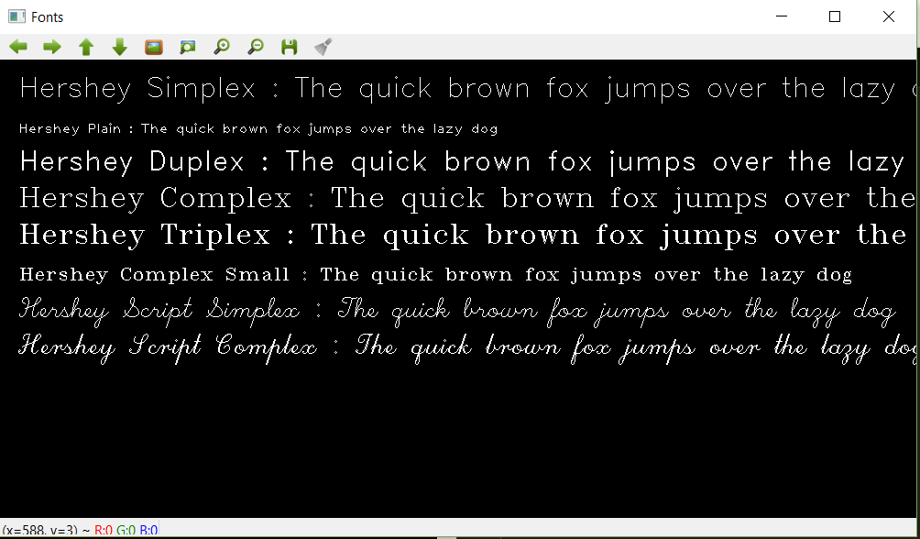
- FONT_HERSHEY_SCRIPT_COMPLEX: More complex handwriting style.
Figure 15: How Different text fonts look like in OpenCV.

5.8. Image Filters:
Image filtering is a process used to modify or improve digital images through mathematical operations. Filters can smooth out noise, highlight edges or change the way an image looks by applying a set of rules to each pixel and its neighbors. It adjusts digital images by applying mathematical operations to each pixel, allowing for effects such as smoothing, sharpening or edge detection.
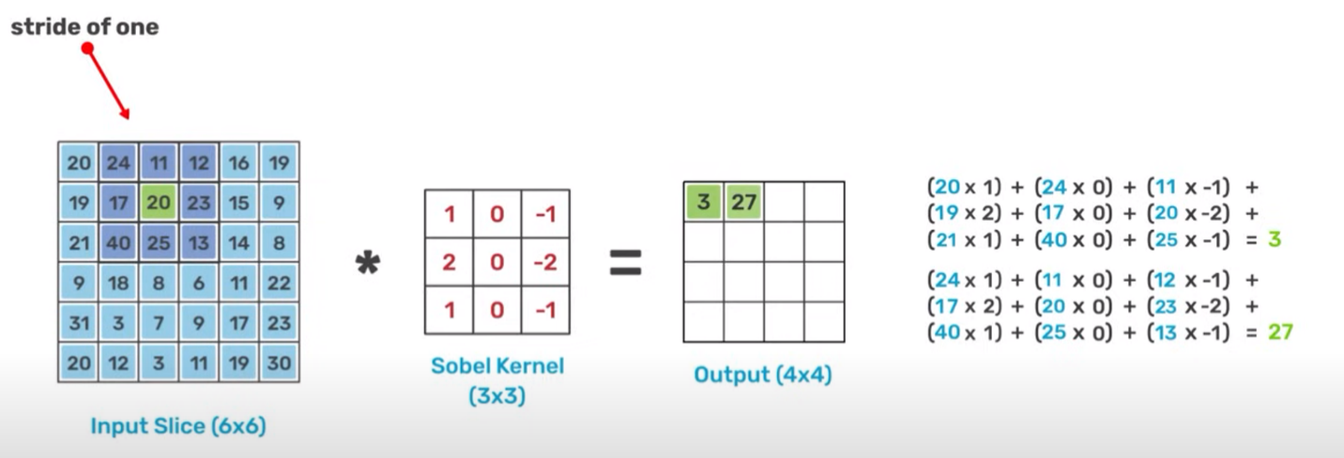
Convolutional operation:
Figure 16: Applying Sobel filter to detect vertical edges of an image.
- The convolution operation is simply the dot product of the kernel matrix to it’s receptive image data.

5.8.1. Types of filter matrices to apply:

1. Prewitt Operator
Like Sobel, but with simpler weights:
Horizontal (Gx): $\left[\begin{matrix}-1 & 0 & 1 \\ -1 & 0 & 1 \\ -1 & 0 & 1\end{matrix}\right]$, for detecting & extracting vertical lines.
Vertical (Gy):$\left[\begin{matrix}-1 & -1 & -1 \\ 0 & 0 & 0 \\ 1 & 1 & 1\end{matrix}\right]$, for detecting & extracting horizontal lines.
Advantages: Computationally efficient and good for detecting horizontal and vertical edges.

2. Sobel Operator
The Sobel operator uses two 3x3 kernels to detect edges in horizontal and vertical directions:
Horizontal (Gx): $\left[\begin{matrix}-1 & 0 & 1 \\ -2 & 0 & 2 \\ -1 & 0 & 1\end{matrix}\right]$, for detecting & extracting vertical lines.
Vertical (Gy):$\left[\begin{matrix}-1 & -2 & -1 \\ 0 & 0 & 0 \\ 1 & 2 & 1\end{matrix}\right]$, for detecting & extracting horizontal lines.
The gradient magnitude is computed as:
G = sqrt(Gx^2 + Gy^2)
Advantages: Simple to implement and effective for detecting edges in noisy images due to its smoothing effect.

5.8.2. Blur Filters:
When we are dealing with images at some points the images will be crisper and sharper which we need to smoothen or blur to get a clean image, or sometimes the image will be with a really bad edge which also we need to smooth it down to make the image usable. In OpenCV, we got more than one method to smooth or blur an image, let's discuss them one by one.

1. Average Blur:
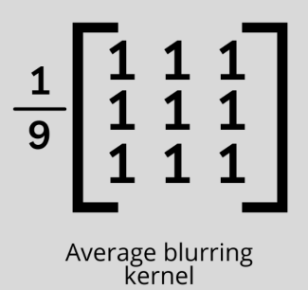
The averaging method is very similar to the 2d convolution method as it follows the same rules to smoothen or blur an image and uses the same type of kernel which will basically set the center pixel’s value to the average of the kernel weighted surrounding pixels. And by this, we can greatly reduce the noise of the image by reducing the clarity of an image by replacing the group of pixels with similar values which is basically similar color. We can greatly reduce the noise of the image and smoothen the image.
Figure 17: Average Blur OpenCV.
Syntax:
cv2.blur(image, shapeOfTheKernel)

Where:
- Image- The image you need to smoothen
- shapeOfTheKernel- The shape of the matrix-like 3 by 3 / 5 by 5

2. Gaussian Blur:
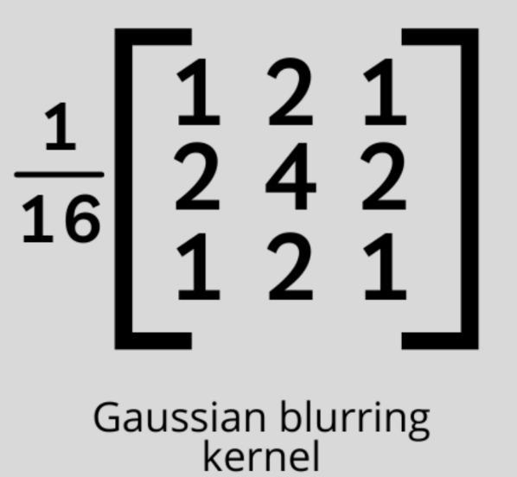
In a gaussian blur, instead of using a box filter consisting of similar values inside the kernel which is a simple mean we are going to use a weighted mean. In this type of kernel, the values near the center pixel will have a higher weight. With this type of blur, we will probably get a less blurred image but a natural blurred image which will look more natural because it handles the edge values very well. Instead of averaging the weighted sum of the pixels here, we will divide it with a specific value which is 16 in the case of a 3 by 3 shaped kernel which will look like this.
Figure 18: Gaussian Blurring Kernel.

Syntax:
cv2.GaussianBlur(image, shapeOfTheKernel, sigmaX)

Where:
- Image- the image you need to blur
- shapeOfTheKernel- The shape of the matrix-like 3 by 3 / 5 by 5
- sigmaX- The Gaussian kernel standard deviation which is the default set to 0

3. Median Blur:
In this method of smoothing, we will simply take the median of all the pixels inside the kernel window and replace the center value with this value. The one positive of this method over the gaussian and box blur is in these two cases the replaced center value may contain a pixel value that is not even present in the image which will make the image’s color different and weird to look, but in case of a median blur though it takes the median of the values that are already present in the image it will look a lot more natural.
- There are no Kernel values for this method (no matrix).
Syntax:
cv.medianBlur(image, kernel size)

Where:
- Image- The image we need to apply the smoothening
- KernelSize- the size of the kernel as it always takes a square matrix the value must be a positive integer more than 2.

5.8.3. Filter Methods:

Filter2d
The cv2.filter2D() function provided by the OpenCV library convolves an image with a kernel. An arbitrary linear filter is applied to the image using this function. Furthermore, the function interpolates outlier pixels according to the border mode specified when the aperture is partially outside the image.
Syntax:
cv2.filter2D(src, dst, ddepth, kernel)
Parameters
- src: Source image or input image
- dst: Output image
- ddepth: Depth of output image (-1 is used to specify the same depth as input image)
- kernel: Defines the kernel
Example to apply kernel of ones to clean image of noise:
# Defining the kernel
kernel = np.ones((5,5),np.float32)/25

# Applying Filter2D function to the image
img = cv2.filter2D(img,-1,kernel)

# Displaying the output image
plt.imshow(img)

Bilateral Filter
In OpenCV, cv2.bilateralFilter() is useful for effectively removing noise from an image without disturbing the edges of the image.
Bilateral filtering takes a Gaussian filter in space and one Gaussian filter which is a function of the difference in pixel values. Only nearby pixels are considered for blurring purposes using the Gaussian function and only pixels with similar intensity values to the central pixel are considered using the Gaussian function of intensity.
Syntax:
cv2.bilateralFilter(src, d, sigmaColor, sigmaSpace, dst=None, borderType=None)
Parameters
- src: Source image or input image
- dst: Output image
- d: Pixel neighborhood diameter used during filtering. If the value is negative, sigmaSpace is for computing the value
- sigmaColor: Color space of the filter
- sigmaSpace: Coordinate space of the filter
- borderType: Type of border
Example code:
# Defining the kernel
kernel = np.ones((5,5),np.float32)/25

# Applying bilateral filter to the image
img = cv2.bilateralFilter(img,10,75,75)

# Displaying the output image
plt.imshow(img)

SQR Box Filter
The SqrBoxFilter in OpenCV is a specialized filter used for efficient image processing. It computes the squared sum of a box filter over an image, which is particularly useful in tasks like variance calculation or local contrast enhancement.
Syntax
cv2.sqrBoxFilter(src, ddepth, ksize, dst=None, anchor=(-1, -1), normalize=True, borderType=cv2.BORDER_DEFAULT)

Parameters
- src: Input image (of type cv2.Mat).
- ddepth: Desired depth of the output image (e.g., cv2.CV_32F or cv2.CV_64F).
- ksize: Size of the kernel (e.g., (width, height)).
- dst: Output image (optional).
- anchor: Anchor point of the kernel (default is (-1, -1), which means the center).
- normalize: Boolean flag to normalize the kernel (default is True).
- borderType: Pixel extrapolation method (e.g., cv2.BORDER_DEFAULT).
Example code:
import cv2
import numpy as np

# Load an image
image = cv2.imread('example.jpg', cv2.IMREAD_GRAYSCALE)

# Apply SqrBoxFilter
result = cv2.sqrBoxFilter(image, ddepth=cv2.CV_32F, ksize=(5, 5))

# Display the result
cv2.imshow('Original Image', image)
cv2.imshow('SqrBoxFilter Result', result)
cv2.waitKey(0)
cv2.destroyAllWindows()

5.9. Edge detection
Edge detection is a key step in many computer vision tasks like object detection, image segmentation, and recognition. Two widely used methods for detecting edges in images are Sobel Edge Detection and Canny Edge Detection.
- There is also Laplacian Edge Detection, but it is rarely used because of bad accuracy and edge detection quality.
Sobel Edge Detection:
Sobel Edge Detection is a straightforward, gradient-based method for detecting edges in images. It employs two 3×3 convolution kernels to estimate the gradient of the image intensity in both horizontal and vertical directions and then combine them to get output image. The magnitude of this gradient highlights the presence of edges.
Features of Sobel Edge detection
- Directional Sensitivity: Sobel edge detection is good for edge detection because it uses two different kernels thus it can detect edges in both the horizontal and vertical phases.
- Noise Reduction: The operator incorporates smoothing or blurring such as the Gaussian blur that helps in removing noise hence the operator is less sensitive to minor changes in the images.
- Gradient Magnitude Calculation: It calculates the gradient computed per pixel which aids in enhancing edges, through quantizing the amount of intensification.
- Simple Implementation: Due to these features, the Sobel operator is easy to implement and it can work in real-time software systems.
- Edge Orientation: Besides, the edges are not only detected but also give information about the orientation of the edges which is very useful for the next levels of image processing.
Canny Edge Detection
Canny Edge Detection is a multi-stage algorithm aimed at optimal edge finding with high accuracy and noise resistance. Its sophisticated design makes it a state-of-the-art edge detector.
Stages of Algorithm
- Noise Reduction: Applies a Gaussian filter to smooth the image and reduce noise.
- Gradient Calculation: Computes the intensity of the gradient and its direction.
- Non-Maximum Suppression: Thins out the edges, retaining only local maxima to yield 1-pixel wide lines.
- Double Thresholding: Classifies pixels as strong, weak or non-edges based on two thresholds.
- Edge Tracking by Hysteresis: Connects edge segments by considering the continuity of weak and strong edges.
Features of Canny Edge Detection
- Explicit Noise Reduction: Initial smoothing makes it robust to noisy images.
- Precision: Superior edge localization due to non-maximum suppression.
- Edge Connectivity: Ensures continuous edge detection via hysteresis thresholding.
- Parameter Flexibility: Allows tuning (e.g., Gaussian kernel size, thresholds) for application-specific performance.

5.9.1. Practical code for Edge Detection Methods:
The Following code has all three most common methods that is (Canny, Laplacian, and Sobel):
# Read image
try:
image = cv.imread('images/Filter_test.jpg')
except Exception as e:
print(f"Exception Occured: {e}")

RGB_img = cv.cvtColor(image, cv.COLOR_BGR2RGB)

# Apply blur then convert to gray scale
blur_img = cv.GaussianBlur(image, (5, 5), 0)
gray_img = cv.cvtColor(blur_img, cv.COLOR_BGR2GRAY)

# Sobel Edge Detection
sobel_x = cv.Sobel(gray_img, cv.CV_64F, 1, 0, ksize=5)
sobel_y = cv.Sobel(gray_img, cv.CV_64F, 0, 1, ksize=5)
sobel_combined = cv.magnitude(sobel_x, sobel_y)

# Laplacian Edge Detection
laplacian = cv.Laplacian(gray_img, cv.CV_64F)
laplacian_abs = cv.convertScaleAbs(laplacian)

# Canny Edge Detection
t_lower, t_upper = 50, 150
canny = cv.Canny(gray_img, t_lower, t_upper)

# Plot all the images
plot_titles = ['Original', 'Sobel Combined', 'Laplacian', 'Canny']
plot_images = [RGB_img, sobel_combined, laplacian_abs, canny]

fig, ax = plt.subplots(2, 2, figsize=(20, 10))
for i in range(4):
ax[i // 2, i % 2].imshow(plot_images[i], cmap='gray')
ax[i // 2, i % 2].set_title(plot_titles[i], fontdict={'fontsize': 30, 'weight': 'bold'})
ax[i // 2, i % 2].axis('off')
plt.tight_layout()
plt.show()

First, we convert the image to grey scale in order to perform Edge Detection.
Then we:
- Use the cv2.Sobel() function to apply Sobel Edge detection for both the x axis and the y axis on the image matrix.
- Use the cv2.Laplacian() Function to apply Laplacian Edge detection.
- Use the cv2.Canny() Function to apply Canny Edge detection.
- Then plot all the images with the original image to compare the algorithms.

5.10. Histogram Equalization:
Histogram Equalization (HE) is a technique used to improve image contrast by redistributing pixel intensity values across the entire range. It is especially effective in images where the foreground and background have similar brightness, making it hard to distinguish details.
- An image histogram is a global description of the aspects of the image. The image histogram provides high quality information about the image. The relative frequency of the occurrence of each gray level of the image is accurately represented by the Image Histogram.

5.10.1. Analyzing an image using histogram
The histogram for an image refers to a visual depiction of the intensity values of the pixels. The histogram of an image is a way of analyzing the image. It is used to understand the global description of the image.
# Compute the histogram for the blue channel (channel index 0)
blue_hist = cv2.calcHist([image], [0], None, [256], [0, 256])

Key Parameters of cv2.calcHist
- images: List of images (e.g., [image]).
- channels: Index of the channel to compute (e.g., [0] for blue, [1] for green, [2] for red).
- mask: Optional mask to compute the histogram for a specific region.
- histSize: Number of bins (e.g., [256] for intensity values from 0 to 255).
- ranges: Range of intensity values (e.g., [0, 256]).
Example code to calculate the Histogram and color histogram of the Image in RGB:
# Importing OpenCV
import cv2

# Importing numpy
import numpy as np

# Importing matplotlib.pyplot
import matplotlib.pyplot as plt

# Reading the image
img = cv2.imread(r"C:\Users\tushi\Downloads\PythonGeeks\deer.png")
img = cv2.cvtColor(img, cv2.COLOR_BGR2RGB)
img_1 = cv2.cvtColor(img, cv2.COLOR_BGR2GRAY)

# Setting the grid size
plt.figure(figsize=(20,20))

# Plotting the original image
plt.subplot(221)
plt.title('Original')
plt.imshow(img)

# Plotting the histogram for the image
img_hist = cv2.calcHist([img_1],[0],None,[256],[0,256])
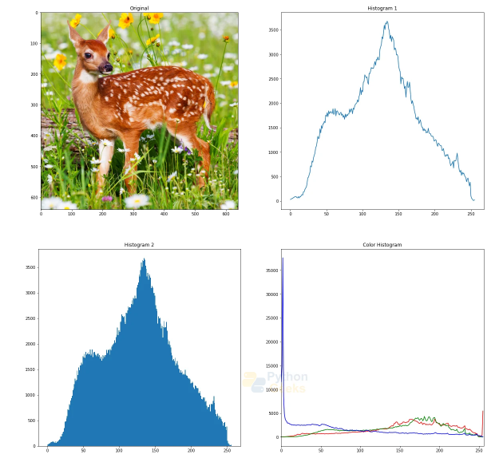
plt.subplot(222)
Figure 19: Image Histogram output.
plt.title('Histogram 1')
plt.plot(img_hist)

# Plotting the histogram using the ravel function
plt.subplot(223)
plt.hist(img_1.ravel(), 256, [0,256])
plt.title('Histogram 2')

# Plotting the histogram for colors in the image
for i, col in enumerate(['r', 'g', 'b']):
hist = cv2.calcHist([img], [i], None, [256], [0, 256])
plt.subplot(224)
plt.title('Color Histogram')
plt.plot(hist, color = col)
plt.xlim([0, 256])

5.10.2. Histogram Equalization in OpenCV
Histogram equalization is an image processing method to adjust the contrast of an image using its intensity distribution histogram.
The equalization method increases the value of global contrast when the close contrast values represent the usable data for the image. Through the adjustments of the contrast values of the image, the intensity distribution of the image becomes clearer. Local regions of the image with lower contrast values gain a higher contrast value.
Histogram equalization method effectively spreads the frequent intensity values of the image. This improves the contrast of the image, while the intensity range of the image is stretched. Images with both dark or bright backgrounds and foregrounds benefit from this method.
cv2.equalizeHist() function in OpenCV performs histogram equalization to improve the contrast of the images and stretch the intensity range for the image histogram. The function takes a grayscale image as the input and returns an equalized image.
Histogram equalization of color images
The channels of the RGB color space represent the intensity of the associated color and not the brightness of the whole image. The application of histogram equalization on the color channels will not give us the desired results. The brightness of the image must be separated from the color channels and then histogram equalization can be applied.
Example code:
# Importing OpenCV
import cv2

# Reading the image
image = cv2.imread(r"C:\Users\tushi\Downloads\PythonGeeks\deer.png")

# Displaying the original image
cv2.imshow('Original', image)
cv2.waitKey(0)
cv2.destroyAllWindows()

# Convert image from RGB to HSV
img_hsv = cv2.cvtColor(image, cv2.COLOR_RGB2HSV)

# Histogram equalisation on the V-channel
img_hsv[:, :, 2] = cv2.equalizeHist(img_hsv[:, :, 2])

# Convert image back from HSV to RGB
image = cv2.cvtColor(img_hsv, cv2.COLOR_HSV2RGB)

# Displaying the image
cv2.imshow("Histogram Equalization", image)
cv2.waitKey(0)
cv2.destroyAllWindows()

5.10.3. CLAHE (Contrast Limited Adaptive Histogram Equalization):
CLAHE (Contrast Limited Adaptive Histogram Equalization) is used to improve the contrast of images. In traditional methods, contrast of whole image changes but CLAHE works by dividing the image into smaller parts and adjust the contrast in each part separately. This helps in avoiding the image getting too bright or too dark in some areas. In this article, we’ll see how to use CLAHE in Python with OpenCV.
When applying CLAHE, there are two parameters to remember:
- clipLimit: This parameter sets the threshold for contrast limiting. By default, value is 40.
- tileGridSize: It is used to divide the image into grids for applying CLAHE. It sets the number of rows and columns. By default, this is 8x8.

5.11. Image Segmentation:
What is Image Segmentation? (The Concept)
Imagine looking at a photo of a person standing in front of a tree. You can instantly identify and separate the "person," the "tree," and the "sky." Image Segmentation is the process of teaching a computer to do this same thing.
In technical terms, Image Segmentation is the process of partitioning a digital image into multiple segments (sets of pixels, also known as super-pixels) to simplify and/or change the representation of an image into something more meaningful and easier to analyze.
The primary goal is to assign a label to every pixel in an image such that pixels with the same label share certain characteristics (like color, intensity, or texture).
A great analogy is a child's coloring book. The outlines of the drawings segment the page into distinct regions (a horse, a castle, a sun). Image segmentation is like automatically drawing those outlines on a real image.
Why is it useful?
- Object Detection and Recognition: Isolating objects from the background is the first step in recognizing them.
- Medical Imaging: Identifying tumors, measuring tissue volumes, or navigating surgery.
- Autonomous Driving: Segmenting a road scene to identify roads, pedestrians, cars, and signs.
- Video Surveillance: Detecting and tracking moving objects.
- Image Editing: Background removal (like a "green screen" effect).

5.11.1. Main Types of Image Segmentation
There are two broad categories:
- Semantic Segmentation: It assigns each pixel a class label (e.g., "car," "road," "person"). It doesn't differentiate between different instances of the same object. If there are two cars in the image, both are simply labeled "car".
- Instance Segmentation: This is a more advanced step. It not only does semantic segmentation but also differentiates between different instances of the same class. So, one car gets the label "car1" and the other gets "car2".
For beginners with OpenCV, we usually start with simpler, traditional techniques that form the foundation.

5.12. Haar Cascade Face Detection
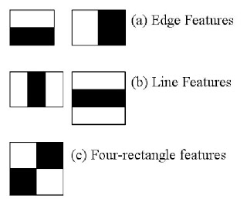
Object Detection using Haar feature-based cascade classifiers is an effective object detection method proposed by Paul Viola and Michael Jones in their paper, "Rapid Object Detection using a Boosted Cascade of Simple Features" in 2001. It is a machine learning based approach where a cascade function is trained from a lot of positive and negative images. It is then used to detect objects in other images.
Figure 20: Haar Cascade feature detection.
Here we will work with face detection. Initially, the algorithm needs a lot of positive images (images of faces) and negative images (images without faces) to train the classifier. Then we need to extract features from it. For this, Haar features shown in the below image are used.
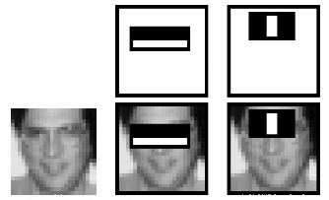
Figure 21: How haar cascade applies the features to detect faces and facial features.
For this, we apply every feature on all the training images. For each feature, it finds the best threshold which will classify the faces to positive and negative. Obviously, there will be errors or misclassifications. We select the features with minimum error rate, which means they are the features that most accurately classify the face and non-face images. (The process is not as simple as this. Each image is given equal weight in the beginning. After each classification, weights of misclassified images are increased. Then the same process is done. New error rates are calculated. Also new weights.
- The process is continued until the required accuracy or error rate is achieved or the required number of features are found).
For this they introduced the concept of Cascade of Classifiers. Instead of applying all 6000 features on a window, the features are grouped into different stages of classifiers and applied one-by-one. (Normally the first few stages will contain very many fewer features). If a window fails the first stage, discard it. We don't consider the remaining features on it. If it passes, apply the second stage of features and continue the process. The window which passes all stages is a face region.

5.12.1. Practical Haar Code
The following code is a full test case for face and eye detection using OpenCV.
- The program uses argparse to make a program in cmd, and detects face and eyes and draws an ellipse around them.
from __future__ import print_function
import cv2 as cv
import argparse
def detectAndDisplay(frame):
frame_gray = cv.cvtColor(frame, cv.COLOR_BGR2GRAY)
frame_gray = cv.equalizeHist(frame_gray)
#-- Detect faces
faces = face_cascade.detectMultiScale(frame_gray)
for (x,y,w,h) in faces:
center = (x + w//2, y + h//2)
frame = cv.ellipse(frame, center, (w//2, h//2), 0, 0, 360, (255, 0, 255), 4)
faceROI = frame_gray[y:y+h,x:x+w]
#-- In each face, detect eyes
eyes = eyes_cascade.detectMultiScale(faceROI)
for (x2,y2,w2,h2) in eyes:
eye_center = (x + x2 + w2//2, y + y2 + h2//2)
radius = int(round((w2 + h2)*0.25))
frame = cv.circle(frame, eye_center, radius, (255, 0, 0 ), 4)
cv.imshow('Capture - Face detection', frame)
parser = argparse.ArgumentParser(description='Code for Cascade Classifier tutorial.')
parser.add_argument('--face_cascade', help='Path to face cascade.', default='data/haarcascades/haarcascade_frontalface_alt.xml')
parser.add_argument('--eyes_cascade', help='Path to eyes cascade.', default='data/haarcascades/haarcascade_eye_tree_eyeglasses.xml')
parser.add_argument('--camera', help='Camera divide number.', type=int, default=0)
args = parser.parse_args()
face_cascade_name = args.face_cascade
eyes_cascade_name = args.eyes_cascade
face_cascade = cv.CascadeClassifier()
eyes_cascade = cv.CascadeClassifier()
#-- 1. Load the cascades
if not face_cascade.load(cv.samples.findFile(face_cascade_name)):
print('--(!)Error loading face cascade')
exit(0)
if not eyes_cascade.load(cv.samples.findFile(eyes_cascade_name)):
print('--(!)Error loading eyes cascade')
exit(0)
camera_device = args.camera
#-- 2. Read the video stream
cap = cv.VideoCapture(camera_device)
if not cap.isOpened:
print('--(!)Error opening video capture')
exit(0)
while True:
ret, frame = cap.read()
if frame is None:
print('--(!) No captured frame -- Break!')
break
detectAndDisplay(frame)
if cv.waitKey(10) == 27:
break

5.12.2. Step by step implementation
Loading Haar Cascade Classifiers
We will load the pre-trained Haar Cascade classifiers for detecting faces and eyes. You can download these classifiers from the OpenCV original GitHub page.
face_cascade = cv2.CascadeClassifier("/content/haarcascade_frontalface_default.xml")
eye_cascade = cv2.CascadeClassifier('/content/haarcascade_eye.xml')

Creating Function to Detect Faces
Now we’ll create a function adjusted_detect_face() to detect faces in an image. This function uses the face cascade classifier to identify face rectangles and draws rectangles around the detected faces.
def adjusted_detect_face(img):
face_img = img.copy()
face_rect = face_cascade.detectMultiScale(face_img, scaleFactor=1.2, minNeighbors=5)

for (x, y, w, h) in face_rect:
cv2.rectangle(face_img, (x, y), (x + w, y + h), (255, 255, 255), 10)

return face_img

Creating Function to Detect Eyes
Similarly, we create a function detect_eyes() to detect eyes using the eye cascade classifier.
def detect_eyes(img):
eye_img = img.copy()
eye_rect = eye_cascade.detectMultiScale(eye_img, scaleFactor=1.2, minNeighbors=5)

for (x, y, w, h) in eye_rect:
cv2.rectangle(eye_img, (x, y), (x + w, y + h), (255, 255, 255), 10)

return eye_img

Finally, Loading an image or video frame

5.12.3. Haar Cascade Face + Eyes Function
The below code is a function using Haar Cascade that takes an input frame and detects both the eyes and face present in the image and draws a rectangle with text over them.
Example Code:
def detect_eyes_and_face(frame):
"""
Function to detect and draw rectangles around eyes and face in an image.
inputs:
frame: The input image in which eyes and face need to be detected.
"""
gray_frame = cv2.cvtColor(frame, cv2.COLOR_BGR2GRAY)

# Equalize using CLAHE
clahe = cv2.createCLAHE(clipLimit=2.0, tileGridSize=(8, 8))
eq_frame = clahe.apply(gray_frame)

# Cascade classifiers for face and eyes
face_cascade = cv2.CascadeClassifier(cv2.data.haarcascades + 'haarcascade_frontalface_default.xml')
eye_cascade = cv2.CascadeClassifier(cv2.data.haarcascades + 'haarcascade_eye.xml')

faces = face_cascade.detectMultiScale(eq_frame, scaleFactor=1.3, minNeighbors=5, minSize=(100, 100))
for (x, y, w, h) in faces:
cv2.rectangle(frame, (x, y), (x + w, y + h), (255, 0, 0), 2, cv2.LINE_AA)
cv2.putText(frame, 'Face Detected', (x, y - 10), cv2.FONT_HERSHEY_SIMPLEX, 0.9, (255, 0, 0), 2, cv2.LINE_AA)
upper_face = eq_frame[y:y + h // 2, x:x + w]
eyes = eye_cascade.detectMultiScale(upper_face, scaleFactor=1.3, minNeighbors=5, minSize=(20, 20))
for (ex, ey, ew, eh) in eyes:
center_x = x + ex + ew // 2
center_y = y + ey + eh // 2
if y < center_y < y + h // 2 and x < center_x < x + w:
cv2.rectangle(frame, (x + ex, y + ey), (x + ex + ew, y + ey + eh), (0, 255, 0), 2, cv2.LINE_AA)
cv2.putText(frame, 'Eye Detected', (x + ex, y + ey - 10), cv2.FONT_HERSHEY_SIMPLEX, 0.7, (0, 255, 0), 2, cv2.LINE_AA)
return frame

6. Pytorch
PyTorch is a deep learning library built on Python. It provides GPU acceleration, dynamic computation graphs and an intuitive interface for deep learning researchers and developers. PyTorch follows a "define-by-run" approach meaning that its computational graphs are constructed on the fly allowing for better debugging and model customization.
PyTorch vs. TensorFlow
This is a common question. The lines have blurred recently, but the traditional distinction was:
- PyTorch: More flexible, intuitive, and "pythonic." Favored by researchers for rapid prototyping and experimentation due to its dynamic graph.
- TensorFlow: Had a more static graph approach (though it now has Eager Execution by default), which was historically better for production deployment (e.g., on mobile devices, browsers, via TensorFlow Serving).
Today, both frameworks are incredibly capable and have adopted each other's best features. The choice often comes down to personal preference, team experience, or specific library support.

6.1. Key Features and Why It's So Popular
PyTorch's design philosophy and features have made it a favorite among researchers and developers.
1. Pythonic and Intuitive
PyTorch feels like a native part of Python. Its code is easy to write and understand because it uses Python's concepts and styles (like classes and conditional statements) seamlessly. This makes it more intuitive for Python developers compared to frameworks that have their own complex static graph definitions.
2. Dynamic Computational Graph (Define-by-Run)
This is arguably PyTorch's "killer feature" that propelled it to fame.
- What it is: The computational graph (which defines the operations on your tensors) is built on-the-fly as your code runs.
- Why it's great:
  - Flexibility: It allows you to use standard Python control flow (like for loops and if statements) within your model's architecture. This is invaluable for variable-length inputs (like sentences in NLP) or more complex, dynamic models like RNNs.
  - Easier Debugging: Because the graph is built step-by-step, you can use standard Python debugging tools (like pdb or print statements) to inspect your tensors and find issues, just like you would with any other Python program.

3. Strong GPU Acceleration
PyTorch makes it incredibly simple to move tensors and models between the CPU and GPU (using NVIDIA CUDA or AMD ROCm). A single call to .to('cuda') is often all it takes to leverage the massive parallel processing power of a graphics card, which is essential for training large neural networks quickly.
4. The torch.autograd Module
This module provides automatic differentiation for all operations on tensors. It automatically calculates the gradients (partial derivatives) needed for optimizing model parameters. This is the engine behind the "backpropagation" algorithm used in training neural networks. You just define the forward pass, and PyTorch handles the backward pass for you.
5. Distributed Training
PyTorch has excellent support for scaling training across multiple GPUs and multiple machines, which is crucial for training large models on massive datasets.
6. The torch.nn Module
This module provides all the essential building blocks you need to create neural networks: layers, loss functions, and optimizers (like SGD, Adam).
7. Thriving Ecosystem and Community
- TorchVision, TorchText, TorchAudio: These are companion libraries that provide datasets, model architectures, and common transformations for computer vision, text, and audio processing.
- Hugging Face Transformers: The entire NLP ecosystem has largely standardized on PyTorch, with libraries like Hugging Face making thousands of pre-trained models available.
- PyTorch Lightning: A very popular lightweight wrapper that organizes PyTorch code to make it more modular and removes a lot of boilerplate, making research more reproducible.

6.2. Tensors in Pytorch
A Pytorch Tensor is basically the same as a NumPy array. This means it does not know anything about deep learning or computational graphs or gradients and is just a generic n-dimensional array to be used for arbitrary numeric computation. However, the biggest difference between a NumPy array and a PyTorch Tensor is that a PyTorch Tensor can run on either CPU or GPU.
There are multiple types of simple tensors we can create:
- Scalar
- 1D matrix
- 2D matrix
- 3D Tensor

Example for defining different types of tensors and printing their dimensions and shapes:
# Creating different types of tensors
x = torch.tensor(42) # Scalar
x1 = torch.tensor([1, 2, 3]) # 1D Matrix
x2 = torch.tensor([[1, 2, 3], [4, 5, 6]]) # 2D Matrix
tensor_3d = torch.tensor([[[1, 2, 3], [4, 5, 6]], [[7, 8, 9], [10, 11, 12]]]) # 3D Tensor

# Printing their dimensions
print(f"The Dimension of x is {x.ndim}D")
print(f"The Dimension of x1 is {x1.ndim}D")
print(f"The Dimension of x2 is {x2.ndim}D")
print(f"The Dimension of 3D tensor is {tensor_3d.ndim}D")

print("\n-----------------------------------------------------------\n")
# Printing their Shapes
print(f"The shape of x is {x.shape}")
print(f"The shape of x1 is {x1.shape}")
print(f"The shape of x2 is {x2.shape}")
print(f"The shape of x is {tensor_3d.shape}")

Tensor attributes:
Each tensor(torch.Tensor) has a torch.dtype, torch.device, and torch.layout attributes.
- torch.dtype: A torch.dtype is an object that represents the data type of torch.Tensor. PyTorch has twelve different data types.
- torch.device: A torch.device is an object representing the device on which a torch.Tensor is or will be allocated. The torch.device contains a device type ('cpu' or 'cuda') and an optional device ordinal for the device type.
To check what type of device the tensor is running on or if it is running on GPU or not:
print(f"Device of tensor: {tensor_3d.device}")
print(f"Is it on GPU (CUDA)? {tensor_3d.is_cuda}")

6.2.1. Indexing & Slicing
Almost all traditional Indexing and Slicing methods can be applied to tensors normally.
- Fancy Indexing
- Boolean Indexing
- Slicing

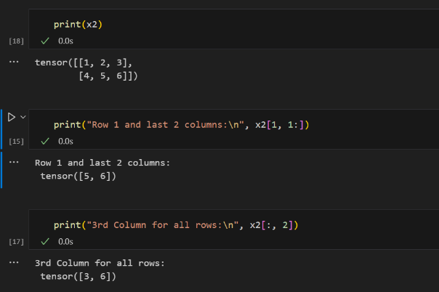
Figure 22: Tensor Indexing & Slicing.

6.2.2. Random Tensors
There are multiple commands to create random tensors:
torch.rand is a function in PyTorch that generates a tensor filled with random numbers drawn from a uniform distribution on the interval [0, 1). It is commonly used for initializing tensors with random values.
Syntax
torch.rand(*size, out=None, dtype=None, layout=torch.strided, device=None, requires_grad=False)
Parameters
- size: A sequence of integers (e.g., torch.rand(3, 4) creates a 3x4 tensor). This defines the shape of the output tensor.
- out (optional): The output tensor to write the result into.
- dtype (optional): The desired data type of the tensor (e.g., torch.float32).
- layout (optional): The desired layout of the tensor (default is torch.strided).
- device (optional): The device where the tensor will be allocated (e.g., cpu or cuda).
- requires_grad (optional): If True, gradients will be computed for this tensor during backpropagation.

- torch.randn() syntax and code:
Torch.randn((num_of_matrices, matrices_rows, matrices_cols)
import torch

x = torch.randn((3, 4, 5))
print(x)
- torch.zeros(): Creates a new Tensor with all elements, initialized as zeros.
import torch
z= torch.zeros([3,3], dtype=torch.int32)
print(z)
- torch.ones(): Creates a new Tensor with all elements, initialized as ones.
import torch

z = torch.ones([3,3])
print(z)
- torch.full() and torch.full_like(): These functions return a Tensor of the required size filled with required fill_value provided. The complete prototype for torch.full() is:
Syntax: torch.full(size, fill_value, out=None, dtype=None, layout=torch.strided, device=None, requires_grad=False)
And torch.full_like() is:
Syntax: torch.full_like(input, fill_value, out=None, dtype=None, layout=torch.strided, device=None, requires_grad=False, memory_format=torch.preserve_format)
import torch

# example of torch.full()
newTensor= torch.full((4, 3), 3.14,dtype= torch.float32)
print(newTensor)
Output:
tensor([[3.1400, 3.1400, 3.1400],
[3.1400, 3.1400, 3.1400],
[3.1400, 3.1400, 3.1400],
[3.1400, 3.1400, 3.1400]])

import torch

# Example for torch.full_like()
x = torch.full_like(newTensor,3.24, dtype=None )
print(x)
Output:
tensor([[3.2400, 3.2400, 3.2400],
[3.2400, 3.2400, 3.2400],
[3.2400, 3.2400, 3.2400],
[3.2400, 3.2400, 3.2400]])
Here a new Tensor is returned, with the same size and dtype as the newTensor which was earlier returned from the torch.full method in the example shown above.

6.2.3. Creating noise image
Creating a noise image is simple, as all we need to create is a random matrix of any given size then plot it as image using OpenCV imshow() command.
For creating a Black and White image:
black_white_noise_img = torch.rand((300, 300))
plt.figure(figsize=(10, 10))
plt.imshow(black_white_noise_img.numpy(), cmap='gray')
plt.title('Black and White Noise Image', fontdict={'fontsize': 30, 'fontweight': 'bold'})
plt.tight_layout()
plt.show()

For creating an RGB noise image:
rgb_noise_image = torch.rand((300, 300, 3))

plt.figure(figsize=(10, 10))
plt.imshow(rgb_noise_image)
plt.title('RGB Noise Image', fontdict={'fontsize': 30, 'fontweight': 'bold'})
plt.tight_layout()
plt.show()

6.2.4. Data types for tensors
Tensor Data Types
Tensors are multi-dimensional arrays used in machine learning frameworks like TensorFlow and PyTorch. They support various data types to handle different kinds of numerical and categorical data. Here's a concise overview:
1. Common Tensor Data Types
- Integer Types:
  - int8, int16, int32, int64: Signed integers with varying bit sizes.
  - uint8, uint16: Unsigned integers (non-negative values).
  - Used for categorical data and indices.
- Floating-Point Types:
  - float16 (Half precision): Lower precision, faster computation, less memory.
  - float32 (Single precision): Standard for most ML tasks.
  - float64 (Double precision): Higher precision, more memory usage.
  - Used for most deep learning tasks.
- Boolean Type:
  - bool: Represents True or False.
  - Used for masks or logical operations.
- Complex Types (in some frameworks):
  - complex64, complex128: For complex numbers (real and imaginary parts).
  - Advanced computations.
2. Framework-Specific Notes
- TensorFlow:
  - Tensors are immutable.
  - Supports additional types like bfloat16 (Brain Floating Point) for efficient training with reduced precision.
- PyTorch:
  - Offers similar types but allows mutable tensors.
  - Includes torch.half, torch.float, torch.double, etc.
3. Choosing the Right Data Type
- Use lower precision (e.g., float16) for faster computation when precision isn't critical.
- Use higher precision (e.g., float64) for tasks requiring numerical stability.
- Use integers for categorical or discrete data.

Changing Data Types
In PyTorch, you can use the .to() method or .type() method to change the data type of a tensor.
Using .to():
import torch

# Example: Convert a tensor to float32
tensor = torch.tensor([1, 2, 3], dtype=torch.int32)
converted_tensor = tensor.to(torch.float32)

print(converted_tensor) # Output: tensor([1., 2., 3.])

Using .type():
# Example: Convert a tensor to float32
converted_tensor = tensor.type(torch.float32)

print(converted_tensor) # Output: tensor([1., 2., 3.])

6.2.5. Tensor Manipulation Cheat Sheet

Tensor Creation
import torch

# From data
x = torch.tensor([1, 2, 3])
x = torch.tensor([[1, 2], [3, 4]])

# Special tensors
zeros = torch.zeros(2, 3) # 2x3 tensor of zeros
ones = torch.ones(2, 3) # 2x3 tensor of ones
eye = torch.eye(3) # 3x3 identity matrix
rand = torch.rand(2, 3) # 2x3 tensor with random values (0-1)
randn = torch.randn(2, 3) # 2x3 tensor from normal distribution
arange = torch.arange(0, 10, 2) # [0, 2, 4, 6, 8]
linspace = torch.linspace(0, 1, 5) # [0.0, 0.25, 0.5, 0.75, 1.0]

# Like other tensors
x_like = torch.zeros_like(x) # Same shape as x, filled with zeros

Basic Properties
x = torch.tensor([[1, 2, 3], [4, 5, 6]])

x.shape # torch.Size([2, 3])
x.size() # torch.Size([2, 3])
x.dim() # 2 (number of dimensions)
x.numel() # 6 (total number of elements)
x.dtype # torch.int64
x.device # device(type='cpu')

Reshaping Operations
x = torch.arange(6) # [0, 1, 2, 3, 4, 5]

# Reshape
x.view(2, 3) # 2x3 tensor
x.reshape(2, 3) # 2x3 tensor (more flexible than view)

# Flatten
x.flatten() # 1D tensor
x.view(-1) # Same as flatten

# Squeeze/Unsqueeze
x = torch.rand(1, 3, 1, 4)
x.squeeze() # Remove dimensions of size 1 → (3, 4)
x.unsqueeze(0) # Add dimension at position 0

# Transpose/Permute
x = torch.rand(2, 3, 4)
x.t() # Transpose 2D tensor
x.transpose(0, 1) # Swap dimensions 0 and 1
x.permute(2, 0, 1) # Reorder dimensions

Indexing and Slicing
x = torch.tensor([[1, 2, 3], [4, 5, 6], [7, 8, 9]])

# Basic indexing
x[0, 1] # 2
x[1] # Second row: [4, 5, 6]
x[:, 1] # Second column: [2, 5, 8]

# Slicing
x[0:2, 1:3] # Rows 0-1, columns 1-2
x[::2, :] # Every other row

# Advanced indexing
mask = x > 5
x[mask] # Elements > 5
x[[0, 2], [1, 2]] # [x[0,1], x[2,2]] → [2, 9]

Mathematical operations
a = torch.tensor([1, 2, 3])
b = torch.tensor([4, 5, 6])

# Element-wise operations
a + b # [5, 7, 9]
a - b # [-3, -3, -3]
a * b # [4, 10, 18]
a / b # [0.25, 0.4, 0.5]
a ** 2 # [1, 4, 9]

# Matrix operations
x = torch.rand(2, 3)
y = torch.rand(3, 4)
torch.matmul(x, y) # Matrix multiplication
x @ y # Same as matmul

# Reduction operations
x = torch.tensor([[1, 2], [3, 4]])
x.sum() # 10
x.mean() # 2.5
x.max() # 4
x.min() # 1
x.std() # Standard deviation

# With dimension parameter
x.sum(dim=0) # Sum along columns: [4, 6]
x.sum(dim=1) # Sum along rows: [3, 7]

Broadcasting
# Tensor (3,) + scalar → (3,)
a = torch.tensor([1, 2, 3])
a + 1 # [2, 3, 4]

# Tensor (3,1) + tensor (1,3) → (3,3)
a = torch.tensor([[1], [2], [3]]) # shape (3, 1)
b = torch.tensor([[1, 2, 3]]) # shape (1, 3)
a + b # shape (3, 3)

Concatenation and Stacking
Syntax
torch.chunk(input, chunks, dim=0)
- input: The tensor to be split.
- chunks: The number of chunks to split the tensor into.
- dim: The dimension along which to split the tensor (default is 0).

Example 1: Splitting into dimension 0
import torch

# Create a tensor
tensor = torch.arange(10)

# Split into 3 chunks along dimension 0
chunks = torch.chunk(tensor, 3)

# Output the chunks
for i, chunk in enumerate(chunks):
print(f"Chunk {i}: {chunk}")

Example 2: Splitting into dimension 1
tensor = torch.arange(12).reshape(3, 4)

# Split into 2 chunks along dimension 1
chunks = torch.chunk(tensor, 2, dim=1)

for i, chunk in enumerate(chunks):
print(f"Chunk {i}:\n{chunk}")

Cheat Sheet:
a = torch.tensor([1, 2, 3])
b = torch.tensor([4, 5, 6])

# Concatenate
torch.cat([a, b]) # [1, 2, 3, 4, 5, 6]
torch.cat([a.unsqueeze(0), b.unsqueeze(0)], dim=0) # Stack rows

# Stack (adds new dimension)
torch.stack([a, b]) # [[1, 2, 3], [4, 5, 6]]

# Split/chunk
x = torch.arange(10)
torch.split(x, 2) # Split into chunks of size 2
torch.chunk(x, 3) # Split into 3 chunks

In-place Operations
x = torch.tensor([1, 2, 3])

# Regular operations (create new tensor)
y = x + 1

# In-place operations (modify existing tensor)
x.add_(1) # x becomes [2, 3, 4]
x.fill_(5) # x becomes [5, 5, 5]

# Common in-place operations: add_(), sub_(), mul_(), div_(), zero_()

GPU Operations
# Move tensor to GPU
if torch.cuda.is_available():
device = torch.device("cuda")
x = x.to(device)
# or
x = x.cuda()

# Move back to CPU
x = x.cpu()

# Check device
x.device

Useful Utility Functions
# Clamping
x = torch.tensor([1, 5, 10, 15])
x.clamp(min=2, max=12) # [2, 5, 10, 12]

# Where
condition = torch.tensor([True, False, True])
x = torch.tensor([1, 2, 3])
y = torch.tensor([4, 5, 6])
torch.where(condition, x, y) # [1, 5, 3]

# Sort
x = torch.tensor([3, 1, 2])
values, indices = torch.sort(x) # values: [1, 2, 3], indices: [1, 2, 0]

6.2.6. Difference between Reshape and View
1. What is reshape?
The reshape function in PyTorch returns a tensor with the same data and number of elements as the input tensor but with a specified shape. When possible, the returned tensor will be a view of the input tensor. Otherwise, it will be a copy.
Syntax:
torch.reshape(input, shape)
- input: The tensor to be reshaped.
- shape: The new shape.

6.3. Creating a Simple Neural Network
Building Neural Network using PyTorch
PyTorch offers two primary methods for building neural networks: using the nn.Module class or the nn.Sequential container.
- Using nn.Module: To create a custom network, subclass the nn.Module class and define the __init__ and forward functions. The __init__ method sets up the layers and parameters, while the forward function defines how input flows through the network and produces output.
- Using nn.Sequential: This container allows you to specify layers in a list. The layers are automatically connected in the order provided.
Steps to Implement a Neural Network in PyTorch:
1. Import Required Modules: Bring in necessary libraries like torch, torch.nn, and torch.optim.
2. Define the Network Architecture: Specify the number and types of layers, activation functions, and output size. You can either subclass torch.nn.Module for custom layers or use preset layers like torch.nn.Linear, torch.nn.Conv2d, or torch.nn.LSTM.
3. Set the Loss Function: Choose a loss function based on your task (e.g., torch.nn.MSELoss for regression, torch.nn.CrossEntropyLoss for classification).
4. Choose an Optimizer: Specify an optimizer like torch.optim.SGD, torch.optim.Adam, or torch.optim.RMSprop to adjust the network’s weights using gradients and learning rates.
5. Train the Network: Perform forward and backward passes through the data and update the weights using the optimizer. Monitor training progress by tracking the loss and additional metrics (e.g., accuracy).
This structure simplifies building and training neural networks in Python with PyTorch.

6.3.1. Defining Neural Network Class
First, we create a simpleNN class using the nn.Module.
For this example, we created a neural network with one input layer, two hidden layers (h1, h2), and one output layer.
For the forward function, each output of hidden layers is passed through a ReLU function until the output is calculated and finally returned.
class simpleNN(nn.Module):
# Our model consisting of two hidden (fully connected) layers and one output layer
def __init__(self, input_size, h1, h2, output_size):
super(simpleNN, self).__init__()
self.fc1 = nn.Linear(input_size, h1)
self.fc2 = nn.Linear(h1, h2)
self.fc3 = nn.Linear(h2, output_size)

# Our Forward Function
def forward(self, x):
x = F.relu(self.fc1(x))
x = F.relu(self.fc2(x))
x = self.fc3(x)
return x

6.3.2. Defining Scoring Criterion and loss functions
There are multiple types of criterion and loss functions but in the code example, I defined the model with the parameters I needed and then used Optimizer ADAM.
model = simpleNN(input_size=4, h1=8, h2=9, output_size=3)
criterion = nn.CrossEntropyLoss()
optimizer = optim.Adam(model.parameters(), lr=0.01)

6.3.3. Using nn.sequential
Using nn.sequential method is similar to the first method but is a bit simpler in code.
For example, this code is used to create a custom neural network classifier for iris dataset:
class iris_classifier(nn.Module):
def __init__(self, input_dim, hidden_dim, output_dim):
super(iris_classifier, self).__init__()
self.network = nn.Sequential(
nn.Linear(input_dim, hidden_dim),
nn.ReLU(),
nn.Linear(hidden_dim, hidden_dim),
nn.ReLU(),
nn.Linear(hidden_dim, output_dim)
)

def forward(self, x):
return self.network(x)

In here:
We defined and input layer that gives to hidden layer 1, then onto the activation function which in this case is ReLU.
Then we define another layer that passes onto ReLU, then another final layer that is the output layer.

6.4. Custom Dataset Loading
What is Dataset and DataLoader in PyTorch?
The Dataset class in PyTorch provides an interface for accessing data. It allows you to define how your data should be read, transformed, and accessed. The DataLoader class, on the other hand, provides an efficient way to iterate over your dataset in batches, which is crucial for training models.

Using PyTorch's Dataset and DataLoader classes for custom data simplifies the process of loading and preprocessing data. By defining a custom dataset and leveraging the DataLoader, you can efficiently handle large datasets and focus on developing and training your models. Whether you're working with images, text, or other data types, these classes provide a robust framework for data handling in PyTorch. This comprehensive approach ensures that your data pipeline is efficient, scalable, and easy to maintain, allowing you to concentrate on building and refining your models.

6.4.1. Implementation of Dataset and DataLoader in PyTorch
The implementation of dataset and dataloader in PyTorch are as follows:
Step 1: Importing Necessary Libraries
First, ensure you have the necessary libraries imported
Step 2: Defining Your Custom Dataset Class
To create a custom dataset, you need to define a class that inherits from torch.utils.data.Dataset. This class must implement three methods: __init__, __len__, and __getitem__.
- __init__: Initializes the dataset with any necessary attributes like file paths or data preprocessing steps.
- __len__: Returns the total number of samples in your dataset.
- __getitem__: Retrieves a sample from the dataset given an index.
Step 3: Preparing Your Data
Next, prepare your data and labels. For demonstration purposes, we'll create random data using NumPy:
Step 4: Creating an Instance of Your Dataset
Create an instance of your custom dataset with the prepared data:
Step 5: Creating a DataLoader
The DataLoader class handles batching, shuffling, and loading the data in parallel. Here's how you create a DataLoader:
- batch_size: Specifies the number of samples per batch.
- shuffle: If set to True, data will be shuffled at every epoch.
- num_workers: Specifies the number of subprocesses to use for data loading
Step 6: Iterating Through the DataLoader
You can now iterate through the DataLoader in your training loop. Each iteration will yield a batch of data and corresponding labels:

6.4.2. Example code:
import torch
from torch.utils.data import Dataset, DataLoader
import torch.nn as nn
import torch.optim as optim
import numpy as np

# Custom Dataset class
class CustomDataset(Dataset):
def __init__(self, data, labels):
self.data = data
self.labels = labels

def __len__(self):
return len(self.data)

def __getitem__(self, idx):
sample = self.data[idx]
label = self.labels[idx]
return sample, label

# Prepare data
data = np.random.randn(100, 3, 32, 32) # 100 samples of 3x32x32 images
labels = np.random.randint(0, 10, size=(100,)) # 100 labels in the range 0-9

# Create Dataset
dataset = CustomDataset(data, labels)

# Create DataLoader
dataloader = DataLoader(dataset, batch_size=4, shuffle=True, num_workers=2)

# Define a simple CNN model
class SimpleCNN(nn.Module):
def __init__(self):
super(SimpleCNN, self).__init__()
self.conv1 = nn.Conv2d(3, 16, 3, 1)
self.conv2 = nn.Conv2d(16, 32, 3, 1)
self.fc1 = nn.Linear(32*6*6, 128)
self.fc2 = nn.Linear(128, 10)

def forward(self, x):
x = torch.relu(self.conv1(x))
x = torch.max_pool2d(x, 2, 2)
x = torch.relu(self.conv2(x))
x = torch.max_pool2d(x, 2, 2)
x = torch.flatten(x, 1)
x = torch.relu(self.fc1(x))
x = self.fc2(x)
return x

model = SimpleCNN()

# Define loss function and optimizer
criterion = nn.CrossEntropyLoss()
optimizer = optim.Adam(model.parameters(), lr=0.001)

# Training loop
num_epochs = 5

for epoch in range(num_epochs):
for batch_data, batch_labels in dataloader:
# Convert numpy arrays to torch tensors
batch_data = torch.tensor(batch_data, dtype=torch.float32)
batch_labels = torch.tensor(batch_labels, dtype=torch.long)

# Zero the parameter gradients
optimizer.zero_grad()

# Forward pass
outputs = model(batch_data)
loss = criterion(outputs, batch_labels)

# Backward pass and optimization
loss.backward()
optimizer.step()

print(f'Epoch [{epoch+1}/{num_epochs}], Loss: {loss.item():.4f}')

6.4.3. Example code for Custom Dataset:
In this example below, we create the Dataset class and assign it depending on the current dataset we’re working on.
Then we pass to the class our “X_train” and “y_train”, and we initiate our DataLoader with the dataset we created, and we specify our batch size and number of workers (CPU cores or CUDA cores).
Then we finally train the model batch by batch so that we don’t run out of memory.
class InsuranceDataset(Dataset):
def __init__(self, X, y):
self.X = X
self.y = y

def __len__(self):
return len(self.X)

def __getitem__(self, idx):
features = torch.tensor(self.X[idx], dtype=torch.float32)
target = torch.tensor(self.y.values[idx], dtype=torch.float32)
return features, target

dataset = InsuranceDataset(X_train, y_train)
dataloader = DataLoader(dataset, batch_size=32, shuffle=True, num_workers=4)

for batch_idx, (features, targets) in enumerate(dataloader):
print(f"Batch {batch_idx+1} :")
print("Features : ", features.shape)
print("Targets : ", targets.shape)
break

epochs = 1000
for epoch in range(epochs):
model.train()

for batch_idx, (batch_X, batch_y) in enumerate(dataloader):
print(f"Current batch : {batch_idx}")
optimizer.zero_grad()
predictions = model(batch_X)
loss = criterion(predictions, batch_y)
loss.backward()
optimizer.step()
print(f'Batch [{batch_idx+1}/{epochs}], Loss: {loss.item():.4f}')

if (epoch+1) % 100 == 0:
print(f'Epoch [{epoch+1}/{epochs}], Loss: {loss.item():.4f}')

6.4.4. Custom Image Dataset Loading
For Training models on images, we need to create a custom image dataset loader class that assigns labels to each image folder in the training file that stores our training images.
For example, this file structure for the images:
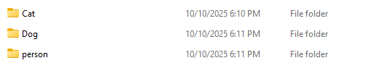
The following figure shows the proper file structure for storing train/test images each in a separate file and each of them are in another separate file Test and Train.
Figure 23: Proper File structure for images.
- This way, we make our dataset loader to access the file path we want using the “os” library (wither it be test or train file path) and then assign each file it’s respective label class name and number and create a dictionary that stores this like {‘0’ : ‘Cat’, ‘1’ : ‘Dog’, ‘2’ : ‘person’}.
class ImageDataset(Dataset):
def __init__(self, image_dir, transform=None):
self.image_dir = image_dir
self.image_paths = []
self.labels = []
self.class_name = {}
self.transform = transform

for label, class_dir in enumerate(os.listdir(image_dir)):
self.class_name[label] = class_dir
class_path = os.path.join(image_dir, class_dir)
for img_name in os.listdir(class_path):
self.image_paths.append(os.path.join(class_path, img_name))
self.labels.append(label)

def __len__(self):
return len(self.image_paths)

def __getitem__(self, idx):
img_path = self.image_paths[idx]
image = Image.open(img_path).convert("RGB")
label = self.labels[idx]

if self.transform:
image = self.transform(image)

return image, label

And then create our train data loader and test data loader:
# Creating our DataLoaders
train_dataset = ImageDataset(image_dir=train_images_dir, transform=transform)
test_dataset = ImageDataset(image_dir=test_images_dir, transform=transform)

train_dataloader = DataLoader(train_dataset, batch_size=32, shuffle=True)
test_dataloader = DataLoader(test_dataset, batch_size=32, shuffle=True)

Image Transforming and how it happens in PyTorch:
In PyTorch using the “transforms” library:
from torchvision import transforms

We can apply multiple “getting ready” operations on the input images such as:
  - Reducing their size (to improve processing speed).
  - Normalizing them.
  - Converting them from numpy arrays to tensors.
  - Etc…
This is what a simple transforms pipeline looks like:
# Transformation Pipeline
transform = transforms.Compose([
transforms.Resize((224, 224)),
transforms.ToTensor(),
transforms.Normalize(mean=[0.485, 0.456, 0.406], std=[0.229, 0.224, 0.225])
])
Where Normalizing is applied like this:
X = 255
normalized_x = (255 – 0.485) / 0.229.
- Where we divide by the standard deviation and subtract the mean.

7. Object Detection

Chapter 8: Image Segmentation
Image Segmentation is a computer vision technique used to divide an image into multiple segments or regions, making it easier to analyze and understand specific parts of the image. It helps identify objects, boundaries and relevant features within an image for further processing.
- It partitions a digital image into discrete groups of pixels—image segments—to inform object detection and related tasks. By parsing an image’s complex visual data into specifically shaped segments.
So, what is the difference between Image Segmentation, Image Classification, and Object Detection?
Image Classification: Is when a model classifies the whole image as a class for example, A model to classify automobiles detected a car in the image so the whole image is in the car class.
Object Detection: Solves image classification problems in that it also offers object localization with classification for example, say the image of an airport contains airplanes and some parked cars, the Classification model might only detect airplanes and so classify it as “airplane” class but the object detection model will draw with bounding boxes exactly where the “airplanes” and “cars” are.
Image Segmentation: Takes Object Detection further by scanning and extracting inherent qualities of each pixel called “heuristics” like color and intensity, where the output is a segmentation mask separating the target pixels from the background or from the other classes present in the image.

8.1. Types of Image Segmentation
There are 3 types of Image Segmentation techniques, each one is different from the other and have certain characteristics and use cases.
1. Semantic Segmentation:
- A semantic segmentation model assigns a semantic class to every pixel but doesn’t output any other context or information (like objects).
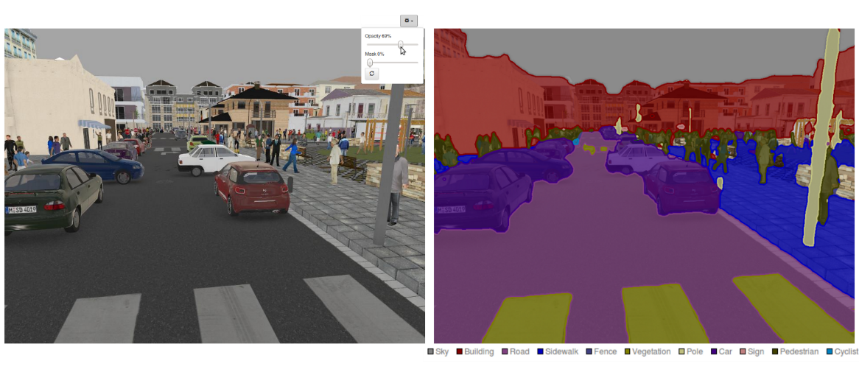
- For example, a semantic segmentation model trained to identify certain classes on a city street would yield segmentation masks indicating the boundaries and contours for each relevant class but not make any distinction between (or count the number of) multiple instances of the same class.
Figure 24: Image showing Semantic Segmentation technique.

2. Instance Segmentation:
- Instance segmentation inverts the priorities of semantic segmentation: whereas semantic segmentation algorithms predict only semantic classification of each pixel (with no regard for individual instances), instance segmentation delineates the exact shape of each separate object instance.
- Instance segmentation isolates things from stuff—which it ignores—and can thus be understood as an evolved form of object detection that outputs a precise segmentation mask instead of an approximate bounding box.
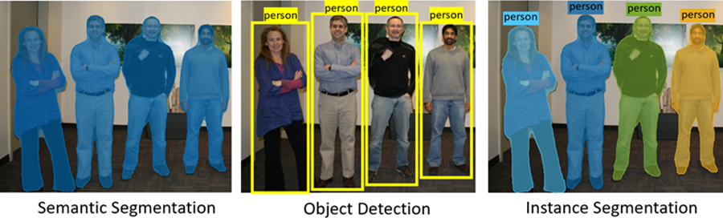
Figure 25: Image Detailing the Difference between Object Detection, Semantic Segmentation, and Instance Segmentation.
Instance Segmentation models have two approaches, either one-shot or two-stage.
For example, Two-stage models like Region-based convolutional networks perform object detection first then segmentation, one-shot models like YOLO performs image classification, object detection, and segmentation simultaneously.
- One-shot models offer faster speed with tradeoff in accuracy while two-stage offers greater accuracy but slower speed.
3. Panoptic Segmentation:
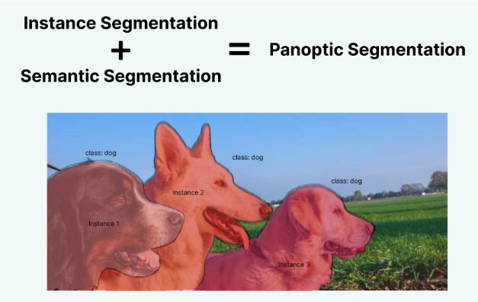
- Panoptic segmentation models both determine semantic classification of all pixels and differentiate each object instance in an image, combining the benefits of both semantic and instance segmentation.
Figure 26: Panoptic Segmentation example.
- In a panoptic segmentation task, each pixel must be annotated with both a semantic label and an “instance ID”. Pixels sharing the same label and ID belong to the same object; for pixels determined to be stuff, instance ID is ignored.

8.2. Image Segmentation Models
1. FCN (Fully Convolutional Network):
- Replaces fully connected layers with convolutions to output a spatial map.
- Uses transposed convolutions (deconvolutions) for up sampling and pixel-wise classification.
- First end-to-end network for semantic segmentation.
2. U-Net:
- Encoder-decoder with skip connections from encoder to decoder.
- Preserves spatial details lost during down sampling.
- Originally designed for biomedical images, it excels with limited data.
3. SegNet:
- Encoder-decoder structure where the decoder uses indices from max-pooling in the encoder (no learned-up sampling).
- Lightweight and memory-efficient, good for real-time applications.
4. DeepLab Series:
- v1/v2: Uses atrous (dilated) convolutions to control resolution and capture context. ASPP samples features at multiple scales.
- v3+: Combines encoder-decoder with ASPP and deeper extraction; improves boundary accuracy.
5. PSPNet (Pyramid Scene Parsing Network):
- Applies a pyramid pooling module to extract global context at different regions.
- Concatenates multi-scale features before final prediction; enhances scene understanding.
6. Mask R-CNN:
- Extends object detection (Faster R-CNN) by adding a branch that outputs binary masks per instance.
- Performs instance segmentation identifies individual objects and their shapes.
7. HRNet (High-Resolution Network):
- Maintains high-resolution representations throughout by using parallel streams.
- Exchanges information across resolutions via fusion blocks.
- Excellent for pose estimation and segmentation needing fine details.
8. Transformer-based Models (e.g., SegFormer, SETR, Swin-UperNet):
- Use vision transformers (ViTs) or hybrid CNN-transformer designs.
- Capture long-range dependencies via self-attention.
9. SegFormer: Simple design—encoder extracts features, lightweight MLP decoder fuses them efficiently. No decoder-encoder attention needed.

Chapter 9: Popular Neural Networks:
This chapter will speak about all the Ready-made Neural Network Architectures and what do they offer.
Each model’s architecture mentioned here will have its own published paper detailing it for further research on the model.
There are a lot of neural networks used, and all of them are separated under performing different tasks, for example:
1. For Image Data (Computer Vision Tasks).
2. Sequential Data (NLP).
3. Generative Modeling.
4. Unsupervised & General learning.
5. Reinforcement Learning.

9.1. Computer Vision Networks:
There are a lot of commonly used Architectures for Computer Vision tasks, including and not limited to:
- LeNet.
- AlexNet.
- VGGNet.
- GoogLeNet / Inception.
- ResNet.
- EfficientNet.
- Vision Transformers (ViT).
- MobileNet.
I will begin by explaining the most important/newest model from these families as often each of them has different versions.

9.1.1. MobileNetV2:

